World War I: RESOURCES
A
F
EE
D
C
B
https://www.pinterest.com/pin/398146423282817633/
https://education.blogs.archives.gov/2013/05/30/propaganda-posters-and-the-common-core/_you_buy_a_liberty_bond-_lest_i_perish__-_nara_-_512671/
THE STRONG ARM OF CANADA
https://www.pinterest.com/pin/470696598533867810/
https://www.trentu.ca/economics/WorkingP
apers/LewMcInnis_Toronto_05.pdf
https://www.bl.uk/world-war-one/articles
/women-in-world-war-one-propaganda
War Profiteering
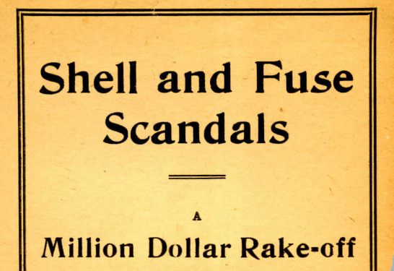
http://wartimecanada.ca/sites/default/files/documents/Shell%20and%20Fuse.pdf
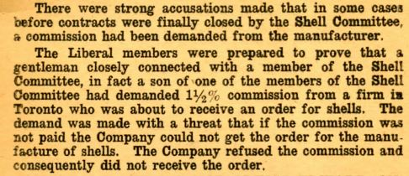
- What is war profiteering?

_________________________________________________
_________________________________________________
_________________________________________________
- Explain why the above source is an example of Canadians involved in war profiteering. Can you think of other examples?

____________________________________________________
___________________________________________________
____________________________________________________

Total War
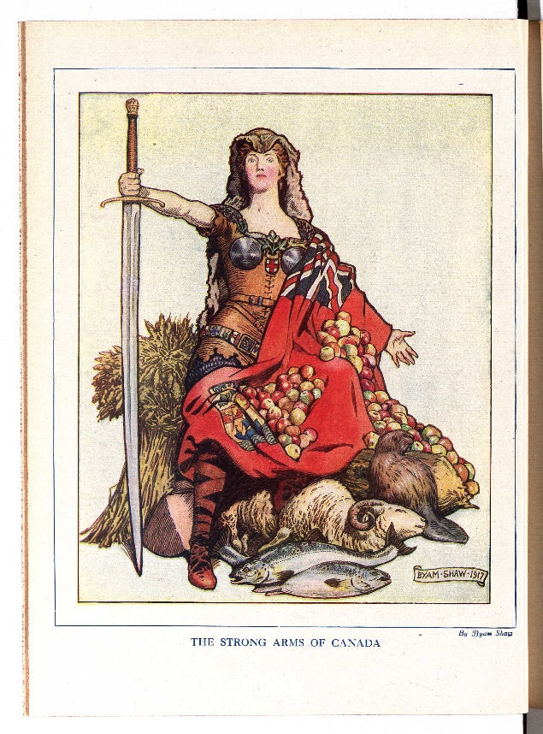 | 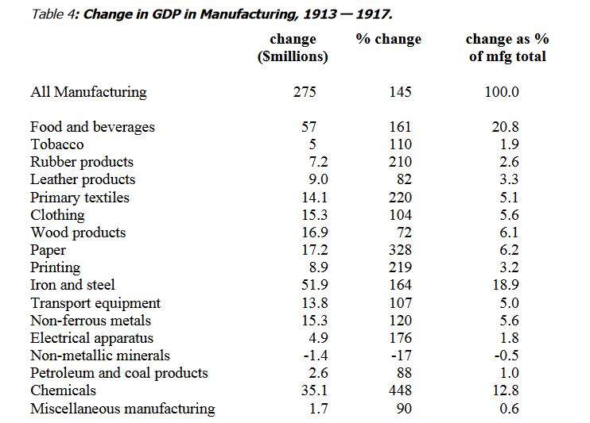
- What message is the cartoonist in Source A trying to convey about Canada’s “Total War” effort during WWI?

- Does this message seem to be supported by Source B. Explain using examples.

___________________________________________________________________________________________

Propaganda
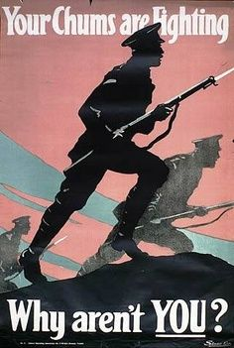
- Which of the above propaganda posters (Sources C-E) would most
likely convince a young Canadian to enlist in WWI? Explain.

- Why would the others not be likely to convince this same Canadian
to enlist?

__________________________________________________________

Women In War  G |  | 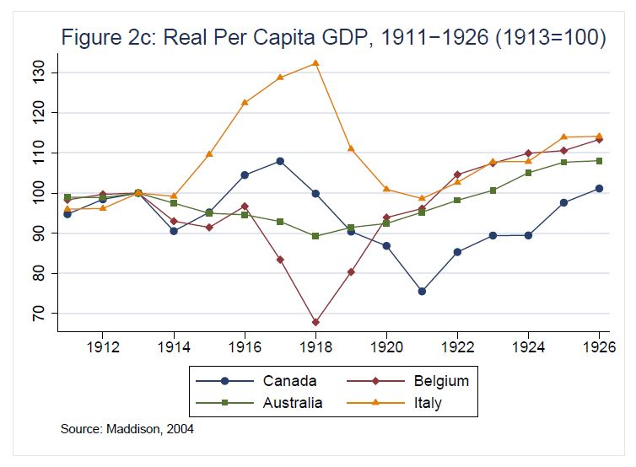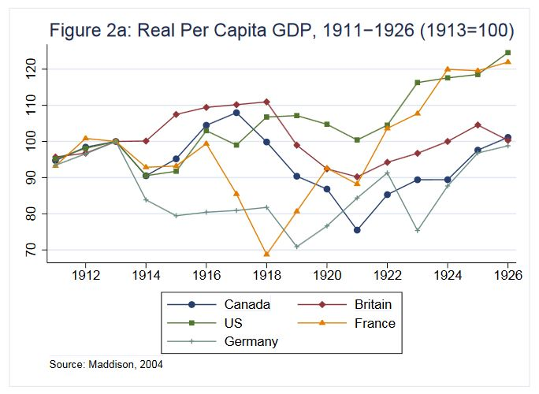  J  I  - WWI became a war of resources. Use Sources I and J to determine who had the upper hand. Explain making reference to the appropriate alliances.  - What important allies are missing?  - What two important events occurred in 1917 that drastically changed the balance of power?  - Analyze Sources I and J. What will happen to the world economy after the war?
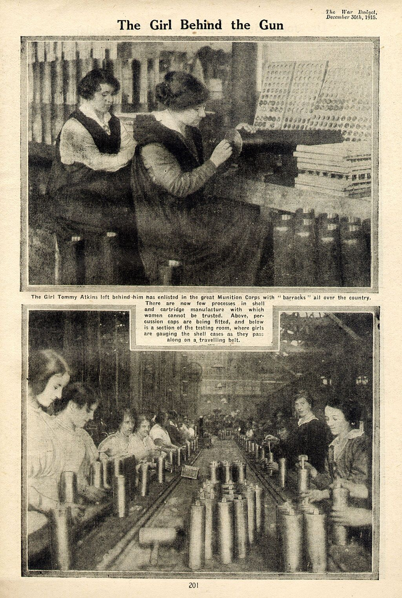 | Why would Nelly McClung have been proud of Canadian women during WWI?  ____________________________________________  ____________________________________________  ____________________________________________  ____________________________________________  ____________________________________________  ____________________________________________  ____________________________________________  ____________________________________________  ____________________________________________  ____________________________________________  ____________________________________________  ____________________________________________  ____________________________________________  ____________________________________________  ____________________________________________  ____________________________________________  ____________________________________________  ____________________________________________  ____________________________________________  What evidence is there in Source G that the status of women was improving during the war?  ____________________________________________  ____________________________________________  ____________________________________________  ____________________________________________  ____________________________________________  ____________________________________________  ____________________________________________  ____________________________________________  ____________________________________________  ____________________________________________  ____________________________________________  ____________________________________________  ____________________________________________  ____________________________________________
“Women who set a low standard for themselves make life hard for all women”
H
Nellie McClung

