Socials 10 Name/Date:
Unit: World War One
Interpreting Sources
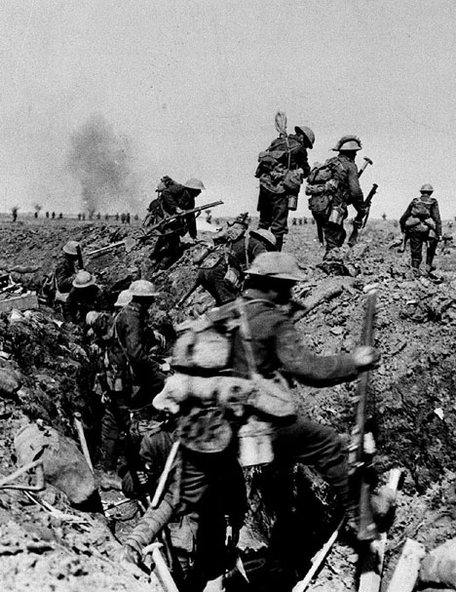
Source B: Soldiers in WWI Trenches
Source A : Victory Bond Posters
What are the men doing in the photo?

Briefly describe the nature of this warfare?

So What? How did the actions in this source affect Canadian soldiers?

What images do you see that stand out for you in this source and explain why?
Who does the person in the picture represent?

Who did this source target as its audience?

So What? How might this poster affect Canadians? Why does that matter?

What images, words, or elements stand out for you in this source and explain why?
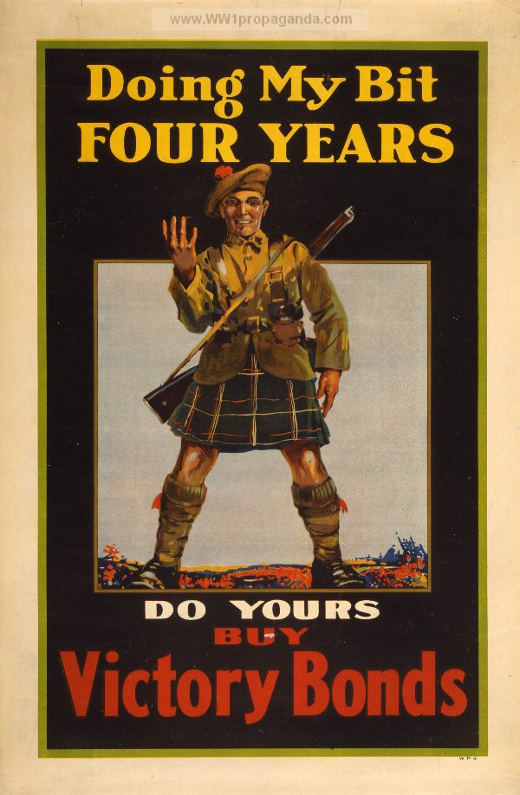
Major Battles of WW I for Canadians:
In each of the 4 Battles listed below, briefly outline the details and implications/outcomes for Canadians.
Ypres- Details-

Implications/Outcomes-

Somme – Details-

Implications/Outcomes-

Vimy Ridge- Details-

Implications/Outcomes-

Passchendaele- Details-

Implications/Outcomes-

