**Technology of World War One**

Document A

**Use Documents D and E to answer the following**

1. Looking at the use of gas as seen in “Document D” identify two advantages and two disadvantages of using gas as a weapon.

Advantages:

Disadvantages:

2. a) Looking at the British soldiers in “Document E” how has the gas attack affected them? Give reasons for your answer.

b) What might be other effects of the gas on these soldiers? Explain.

4. After WW 1, gas as a weapon was banned by the Geneva Convention. Why do you think this happened?

**Document D** – Chlorine attack during WW 1

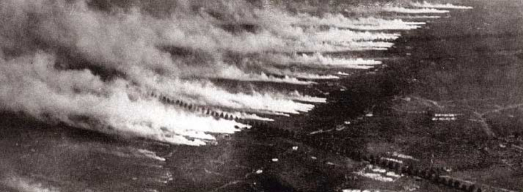

en.wikipedia.org/wiki/Chemical_warfare

**Document E** – British soldiers after a German gas attack

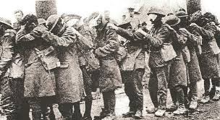

greatwarproject.org/2015/04/22/a-new-terrifying-weapon-gas/

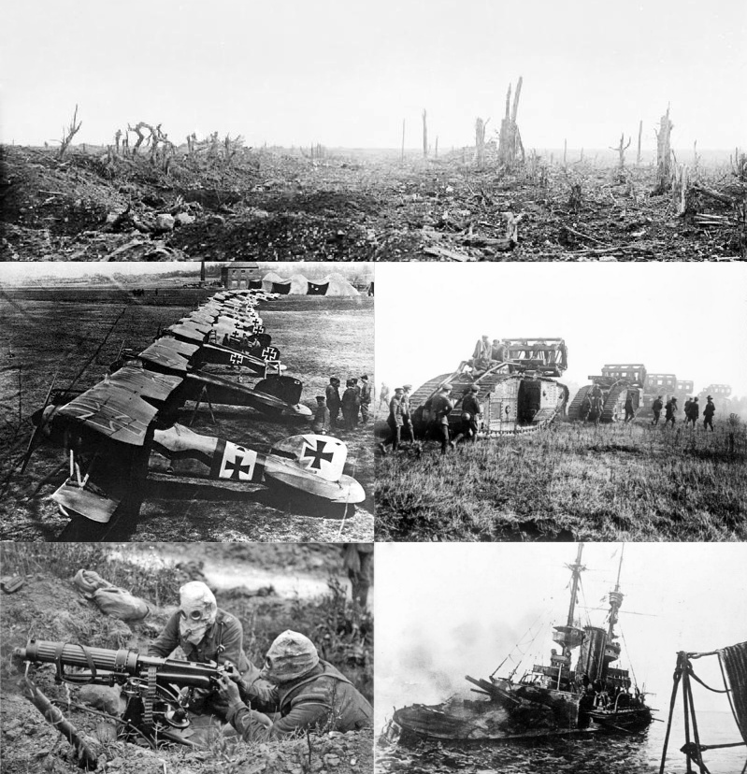

**Look at the pictures titled Document A answer the following.**

1. Identify six weapons of World War One (WW 1) that are shown in the images, or may have been caused by what is seen in the images, of “Document A”?

i. ii. iii.

iv. v. vi.

2. a) Which of the above technological advances was an innovation created during WW 1?

b) Why was it necessary for this new weapon to be developed? What was it hoped that this new weapon would achieve?

3. In what way do the images in “Document A” show that WW 1 was a total war?

wikipedia.org/wiki/World_War_I#/media/File:WWImontage.jpg

**Document B**

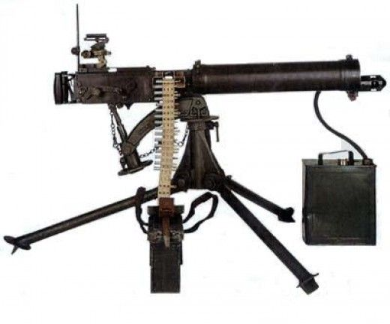

**Document F** – WW 1 U-boat

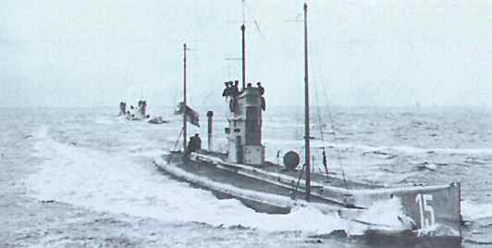

http://uboat.net/history/wwi/part1.htm

**Document G** – Convoy of ships in the North Atlantic in 1916

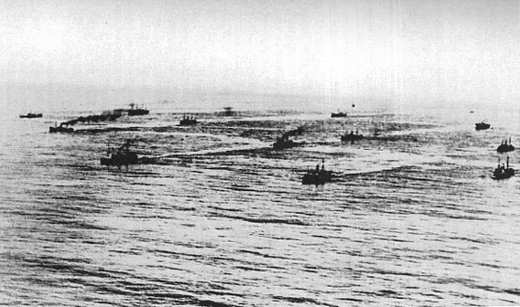

**naval-history.net/WW1Book-MN3b-Merchant_Navy_in_WW1_Hurd.htm**

**Use Documents F and G to answer the following**

1. Looking at the image in “Document F”, identify two ways that U-boats changed the war at sea during WW 1?

i.

ii.

2. a) Why was it necessary for the Allies to use convoys, as seen in “Document G”, to ship goods and supplies from Canada to Britain?

3. During WW 1 the use of U-boats, by Germany, was seen by many as inhumane. Why do you think is was so?

**Use Documents B and C to answer the following**

1. Why did the technology shown in “Document B” revolutionized warfare during WW 1?

2. a) What does the quote in “Document C” say about General Haig’s view of casualties during war?

b) Do you think that other commanders would have shared the same view as Haig? Explain.

3. How would the views expressed by Haig in “Document C” help to explain the number of casualties caused by the weapon in “Document B” to increase during the Battle of the Somme and WW 1 in general?

pinterest.com/pin/374643262731725973/

**Document C** - "The nation must be taught to bear losses. No amount of skill on the part of the higher commanders, no training, however good, on the part of the officers and men, no superiority of arms and ammunition, however great, will enable victories to be won without the sacrifice of men's lives. The nation must be prepared to see heavy casualty lists."

- Written by British commander Haig in June 1916 before the Battle of the Somme began.

[militarian.com/threads/ww1-quotes.6953/](http://www.militarian.com/threads/ww1-quotes.6953/)