Socials 10 Name/Date:

Topic: Residential School System
Assignment: Goals of Residential Schools

Instructions: Read the following comments. Try and summarize the comments into 5 main goals based on the comments.
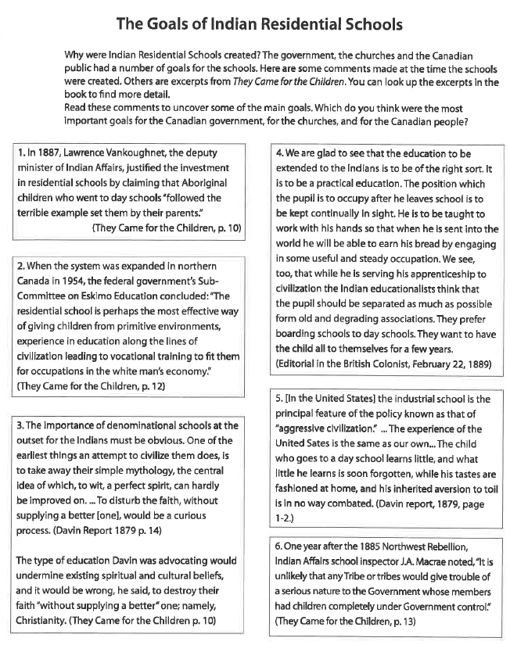
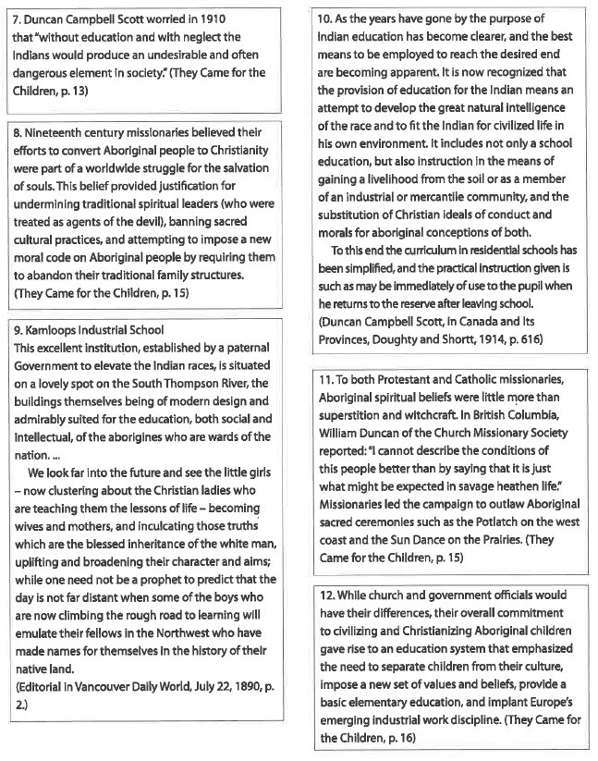

Goals of the Residential Schools: summarize the comments into 5 main goals. Put the number of the comment (s) that support or illustrate that goal.
Goal 1: | Comments that support the Goal:
Goal 2: | Comments that support the Goal:
Goal 3: | Comments that support the Goal:
Goal 4: | Comments that support the Goal:
Goal 5: | Comments that support the Goal:

