Socials 10 Name/Date:

Topic: Residential School System
Assignment: Day School Source Analysis

Instructions: Read the following excerpt from a report written by the Indian Agent Thomas Deasy to the Superintendent of Indian Education in 1911. Highlight any statements Deasy makes that give you a clue as to how he felt about First Nations people. Then answer the questions that follow.

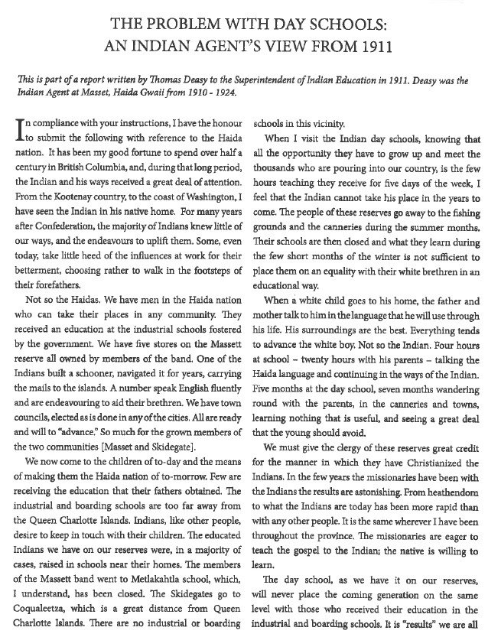
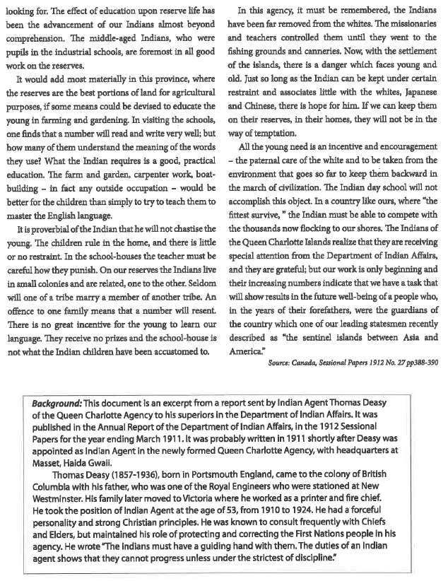

Thinking it Through:
- Is this a primary or secondary source?

- What was the purpose of the source (why was it created)?

- What are some assumptions Deasy makes about First Nations society?

- List any specific words or phrases that reveal Deasy’s bias towards First Nations.

- What are his arguments against Day Schools?

- What is Deasy’s goal for the First Nations people?

- In Deasy’s opinion what are the barriers to progress for Frist Nations?

- What evidence is there in the document that suggests that Deasy’s ideas reflect the views of the larger society at the time?

