 | 6/8/2018 | [Edition 1, Volume 1]

History 12 Times

Cambodian genocide

The Khmer Rouge took control of the Cambodian government in 1975, with the goal of turning the country into a communist agrarian utopia. In reality, they emptied the cities and evacuated millions of people to labor camps where they were starved and abused. [1]

The Khmer Rouge
  - 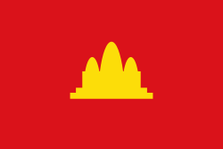- [3] The flag of Democratic Kampuchea. The design was used by Khmer
If you have a disease of the old society, take a dose of Lenin as medication. [6]
-Pol Pot
The Khmer Rouge was the name given to Cambodian communists and later the followers of the Communist Party of Kampuchea in Cambodia, The Khmer Rouge's army was slowly built up in the jungles of Eastern Cambodia during the late 1960s and was supported by the North Vietnamese army, the Viet Cong, and the Pathet Lao. The Khmer Rouge won the Cambodian Civil War when, in 1975, they captured the Cambodian capital and overthrew the government of the Khmer Republic. Following their victory, the Khmer Rouge, led by Pol Pot, Nuon Chea, Ieng Sary, Son Sen, and Khieu Samphan installed a government called the Democratic Kampuchea. [2]

Pol Pot
Pol Pot, meanwhile, joined the proto-communist Khmer People’s Revolutionary Party, which had been set up in 1951 under the auspices of the North Vietnamese. From 1956 to 1963, Pol Pot taught history, geography and French literature at a private school while simultaneously plotting a revolution. In 1960 Pol Pot helped to reorganize the KPRP into a party that specifically espoused Marxism-Leninism. Three years later, following a clampdown on communist activity, he and other party leaders moved deep into the countryside of northern Cambodia, encamping at first with a group of Viet Cong. Pol Pot, who had begun to emerge as Cambodian party chief, and the newly formed Khmer Rouge guerilla army, launched a national uprising in 1968. Their revolution started off slowly, though they were able to gain a foothold in the sparsely populated northeast.[4]

The Khmer Rouge regime was extremely brutal. The regime singled out doctors, teachers, monks, journalists, the rich, artists, anyone with an education, and ethnic or religious minorities. But they also executed people who could no longer work or make the journey to the camps, those perceived to be in opposition to the party, as well as their families so that they could not be chased down for revenge. Unlike in other genocides, no one was immune from being branded an enemy of the state. Many Khmer Rouge members were also killed during purges. Children and babies were not exempt from their cruelty; Pol Pot quoted “to stop the weeds you must also pull up their roots.” No evidence was needed in order to send one to prison and people often fabricated their confessions of various crimes, with the belief that this would end their torment. In reality, they were more often than not executed once they gave up a list of names of new people to arrest. [7]
I see ... a pile of skulls and bones. For the first time since my arrival, what I see before me is too painful, and I break down completely. These are my relatives, friends and neighbors, I keep thinking ... It is a long time before I am calm again. [5]
- Dith Pran. A Cambodian photojournalist best known as a refugee and survivor of the Cambodian genocide.
In the beginning, executions were not necessary – starvation served as an effective tool to dispose of undesirable populations, but as more and more people were sent to prison, the Khmer Rouge moved over to a system of “killing fields,” establishing hundreds all over Cambodia. As the genocide progressed, survival was determined by one’s ability to do work on the collective farms. This meant many of Cambodia’s elderly, handicapped, ill, and children became targets due to their inability to undertake harsh manual labor. Money, free markets, schools, private property, foreign styles of clothing, religious practices, and other aspects of traditional Khmer culture were abolished, and buildings such as schools, pagodas, and government properties were turned into prisons, stables, camps, and granaries. Family relationships were heavily criticized, and the Khmer Rouge insisted that everyone consider “Angka” as their mother and father. Child soldiers were a huge tool of the Khmer Rouge, as they were easy to control and would follow orders without hesitation, to the point where many were forced to shoot their own parents. [7]

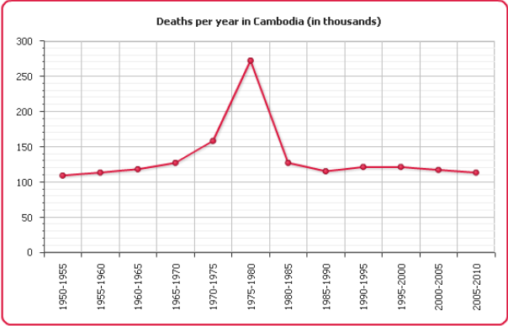

[8]
Cambodian death rates during the genocide.
International Response

The international community was largely silent during the course of the genocide. Neither the U.S. nor Europe called attention to the genocides as they were happening, although scholars and others in the West tried to bring attention to the atrocities being committed. At this time the U.S. had just lost the war in Vietnam, resulting in the government’s reluctance to involve itself in the region again. While their public stance against the killing gradually strengthened, it did not amount to action. It wasn’t until the regime was overthrown that the atrocities that had been committed gained the focus of the international media. However, this still did not lead to an international investigation. [9]
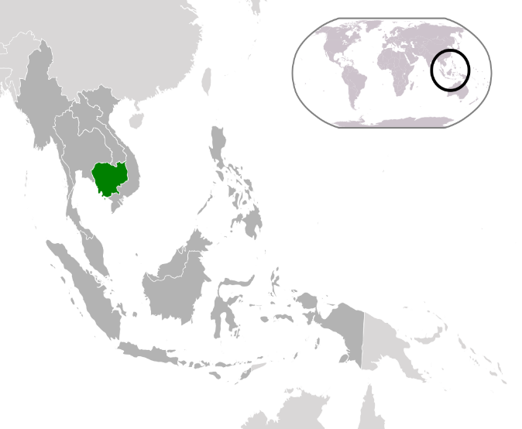[10] cAMBODIA

The killing feilds

The killing fields (though there are many killing fields spread throughout Cambodia) lies a few kilometers outside of Phnom Penh. There, the Khmer Rouge would force their victims to dig trenches or pits and then line them up along the edge and bludgeon or bayonet them to death. The bodies would fall into the pits and dirt would be poured over the bodies, thus burying them. Some of the victims, of course, would be still alive when buried. There is a seven story marble building which houses the bones and skulls of the victims excavated so far. However, there are still so many people buried there that haven't been excavated that when you walk along the paths, the bones and clothing are coming to the surface from erosion. [11]

The fall of the khmer rouge
On January 7, 1979, Vietnamese troops seize the Cambodian capital of Phnom Penh, toppling the brutal regime of Pol Pot and his Khmer Rouge. In 1985, Pol Pot officially retired but remained the effective head of the Khmer Rouge, which continued its guerrilla actions against the government in Phnom Penh. In 1997, however, he was put on trial by the organization after an internal power struggle ousted him from his leadership position. Sentenced to life imprisonment by a “people’s tribunal,” which critics derided as a show trial, Pol Pot later declared in an interview, “My conscience is clear.” Much of the international community hoped that his captors would extradite him to stand trial for his crimes against humanity, but he died of apparently natural causes while under house arrest in 1998. [13]

SIgnificance
The Cambodian Genocide was horrific. 25% (1.7-2 million people) of Cambodia's population was killed. Anyone who protested or tried to run away was tortured and/or killed. Millions of people were ripped from their homes and families- in most cases, never seeing them again. The main goal was to abolish most luxuries, order, and technology, as well as returning all of Cambodia back to its basic years. By doing this a utopia would be created according to Pol Pot. [14] This genocide was a good example of how it still happens across the world even after the brutal Holocaust of World War Two. It shows how there are still people who can obtain power with the same mindset as Adolf Hitler. And will, even after the Holocaust, go to extreme levels to achieve their ideologies no matter how crazy they can be.

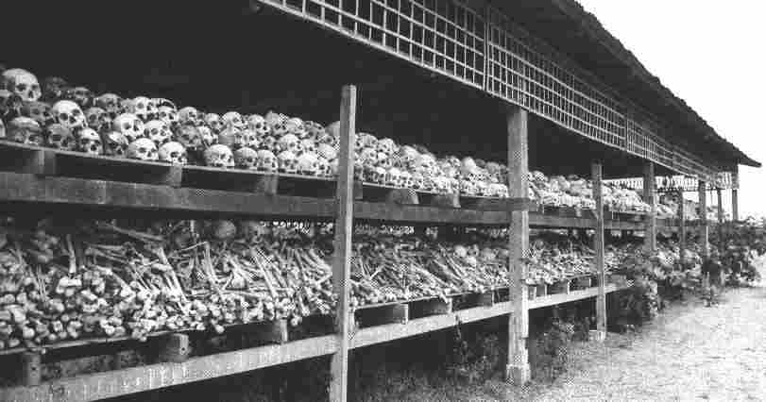 [15]
Rows of skulls and bones from the Cambodian Genocide

Footnotes

[1] "The Cambodian Genocide - United to End Genocide." $site. June 11, 2018. $publisher, Web. June 11, 2018. http://endgenocide.org/learn/past-genocides/the-cambodian-genocide/
[2]. "Khmer Rouge - Wikipedia". $site. June 11, 2018. $publisher, Web. June 11, 2018. https://en.wikipedia.org/wiki/Khmer_Rouge
[3]. "Flag of Democratic Kampuchea - Khmer Rouge - Wikipedia". $site. June 11, 2018. $publisher, Web. June 11, 2018. https://en.wikipedia.org/wiki/Khmer_Rouge#/media/File:Flag_of_Democratic_Kampuchea.svg
[4] "Pol Pot - Facts & Summary - HISTORY.com." $site. June 11, 2018. $publisher, Web. June 11, 2018. https://www.history.com/topics/pol-pot
[5] "TOP 5 QUOTES BY DITH PRAN | A-Z Quotes." $site. June 11, 2018. $publisher, Web. June 11, 2018. http://www.azquotes.com/author/22550-Dith_Pran
[6] "Pol Pot quote: If you have a disease of the old society, take...." $site. June 11, 2018. $publisher, Web. June 11, 2018. http://www.azquotes.com/quote/1275746
[7] The Vietnamese. The. (2018) The Cambodian Genocide - United to End Genocide. Retrieved June 12, 2018, from http://endgenocide.org/learn/past-genocides/the-cambodian-genocide/
[8] Rouge Leader. (2018) Pol pot genocide by jtwin - Infogram. Retrieved June 12, 2018, from https://infogram.com/pol-pot-genocide-1g6qo2qvrjxwp78
[9] "The Cambodian Genocide - United to End Genocide." $site. June 13, 2018. $publisher, Web. June 13, 2018. http://endgenocide.org/learn/past-genocides/the-cambodian-genocide/
[10] "Location Cambodia ASEAN - Cambodia - Simple English Wikipedia, the free encyclopedia". $site. June 14, 2018. $publisher, Web. June 14, 2018. https://simple.wikipedia.org/wiki/Cambodia#/media/File:Location_Cambodia_ASEAN.svg
[11] The Thousands Raised. (2018) The Killing Fields. Retrieved June 14, 2018, from http://www.roch.edu/course/doors2cambodia/cambodia._killing_fields.html
[12] Rithy Panh. Rithy. (2018) The Khmer Rouge's violation of the human rights : The Killing Fields, S-21. Retrieved June 14, 2018, from http://thachandkevinlovescambodia.blogspot.com/2013/04/the-killing-fields-photograph-of.html
[13] Submitting Your Information. (2018) Pol Pot overthrown - Jan 07, 1979 - HISTORY.com. Retrieved June 14, 2018, from https://www.history.com/this-day-in-history/pol-pot-overthrown
[14] “The Basic Facts - Cambodian Genocide." $site. June 15, 2018. $publisher, Web. June 15, 2018. https://sites.google.com/site/cambodiagenocide2011com/home/the-basic-facts
[15] "Cambodian Genocide Pictures - Cambodian Genocide." $site. June 15, 2018. $publisher, Web. June 15, 2018. https://cambodiangenocideresearch.weebly.com/cambodian-genocide-pictures.html

bibliography

"A-Z Quotes | Quotes for All Occasions." $site. June 15, 2018. $publisher, Web. June 15, 2018. http://www.azquotes.com/
"Cambodian Genocide Pictures - Cambodian Genocide." $site. June 15, 2018. $publisher, Web. June 15, 2018. https://cambodiangenocideresearch.weebly.com/cambodian-genocide-pictures.html
"Flag of Democratic Kampuchea - Khmer Rouge - Wikipedia". $site. June 15, 2018. $publisher, Web. June 15, 2018. https://en.wikipedia.org/wiki/Khmer_Rouge#/media/File:Flag_of_Democratic_Kampuchea.svg
"Location Cambodia ASEAN - Cambodia - Simple English Wikipedia, the free encyclopedia". $site. June 14, 2018. $publisher, Web. June 14, 2018. https://simple.wikipedia.org/wiki/Cambodia#/media/File:Location_Cambodia_ASEAN.svg
"Pol Pot - Facts & Summary - HISTORY.com." $site. June 15, 2018. $publisher, Web. June 15, 2018. https://www.history.com/topics/pol-pot
"Pol pot genocide by jtwin - Infogram." $site. June 15, 2018. $publisher, Web. June 15, 2018. https://infogram.com/pol-pot-genocide-1g6qo2qvrjxwp78
"Pol Pot overthrown - Jan 07, 1979 - HISTORY.com." $site. June 15, 2018. $publisher, Web. June 15, 2018. https://www.history.com/this-day-in-history/pol-pot-overthrown
"Khmer Rouge - Wikipedia". $site. June 15, 2018. $publisher, Web. June 15, 2018. https://en.wikipedia.org/wiki/Khmer_Rouge
"The Basic Facts - Cambodian Genocide." $site. June 15, 2018. $publisher, Web. June 15, 2018. https://sites.google.com/site/cambodiagenocide2011com/home/the-basic-facts
"The Cambodian Genocide - United to End Genocide." $site. June 15, 2018. $publisher, Web. June 15, 2018. http://endgenocide.org/learn/past-genocides/the-cambodian-genocide/
"The Khmer Rouge's violation of the human rights : The Killing Fields, S-21." $site. June 15, 2018. $publisher, Web. June 15, 2018. http://thachandkevinlovescambodia.blogspot.com/2013/04/the-killing-fields-photograph-of.html
"The Killing Fields." $site. June 15, 2018. $publisher, Web. June 15, 2018. http://www.roch.edu/course/doors2cambodia/cambodia._killing_fields.html

