History 12 Name/Date:

Unit 2: Promise and Collapse
Topic: U.S. – The Interwar Years
Assignment: Exploring the Boom and the Bust
Reference: Student Workbook pp. 62-73
http://memory.loc.gov/ammem/fsahtml/fahome.html
http://www.ecommcode.com/hoover/hooveronline/hoover_and_the_depression/letters/index.html
http://lcweb2.loc.gov/ammem/afctshtml/tshome.html
http://history1900s.about.com/od/photographs/tp/greatdepressionpictures.htm
http://www.shmoop.com/greatdepression/botw/primarysources.html?d=http://historymatters.gmu.edu/d/5111/
Other online sources

Task: Examine a variety of online primary source documents, including images, letters and speeches that illustrate the effects of the Great Depression. Some examples may include:
- Letters to Herbert Hoover from desperate families
- Drought on the pairies
- Breadlines or soup kitchens

In a chart similar to the one below and record your impressions based on the source focussing on questions such as:
- What do the images/documents show?
- What do they reveal about the time period and how they lived?
- How do images demonstrate a change from the “roaring twenties”?

Primary Source | Reference (link) | Impression
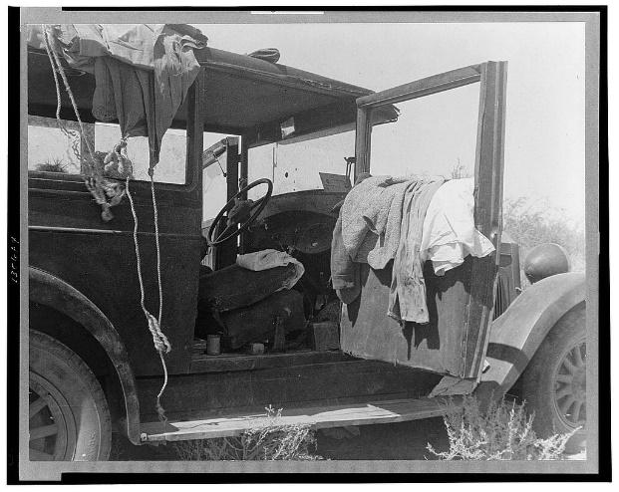 | http://cdn.loc.gov/service/pnp/cph/3c30000/3c30000/3c30600/3c30684v.jpg | This picture really shows the terrible effect the Depression had on families. This unfortunate family is living out of their car. They do own a car, so obviously at one point they did have some money, but sadly, it seems like not anymore
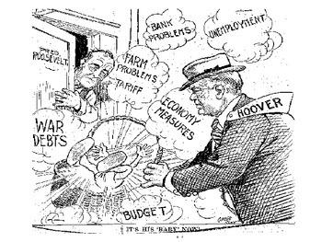 | https://www.teacherspayteachers.com/Product/Great-Depression-1930s-Political-Cartoon-Analysis-1670301 | This 1930s cartoon shows what the American people thought of President Hoover’s actions during the depression. His laissez-faire attitude worked just fine during the good times, but when things got bad, he did not step up. The American people felt abandoned by him. Conversely, the saw Franklin Roosevelt as a saviour and a ray of hope! He could save them from these tough times
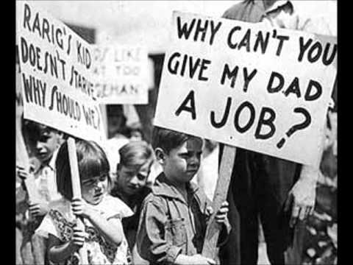 | http://www.blog44.ca/cashelf/2017/01/16/wwiis-impact-on-canadas-great-depression/ | This picture shows us how impacted not only the adults of the great depression were, but the effects that it had on the children. They were too young to comprehend what was going on. Where had his old life gone? Why was his dad not working? All questions too difficult for a young boy to understand.
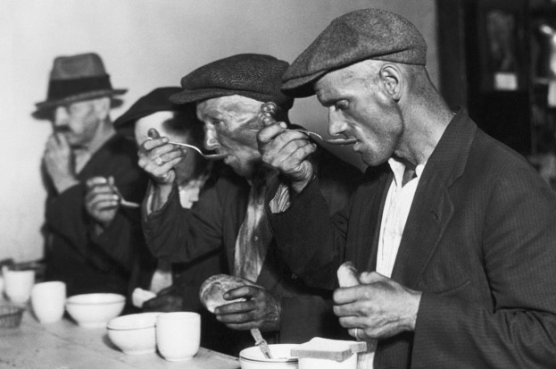 | http://www.historyrevealed.com/sites/default/files/imagecache/623px_wide/Depression%205.jpg | The Great depression drastically reduced people’s quality of life. These are previously wealthy men getting a private food bank meal. The food looks grim, and the men look sickly and unhealthy.
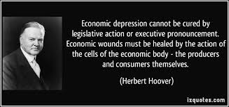 | https://encrypted-tbn0.gstatic.com/images?q=tbn:ANd9GcSCJLdaPWKBLxCTVCWqauIHublV-7LqTtnheCVjidU1YYdxKV5U | This quote from President Hoover gives us a glimpse into what he thought about the depression, and perhaps why it got to such a low under his control. His “leave it to the people” attitude obviously did not work, ad is the main reason he did not get re-elected.
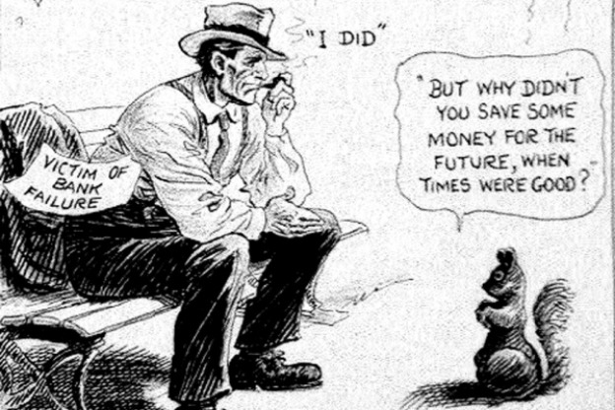 | https://mtviewmirror.com/wp-content/uploads/McCutcheon-Wise-Economist.jpg | This cartoon shows us just how unavoidable and tough the depression was. It hit so hard that even the wealthy and stable were stricken with poverty. No one was safe in the depression. Even if you thought you had saved enough money, you were wrong
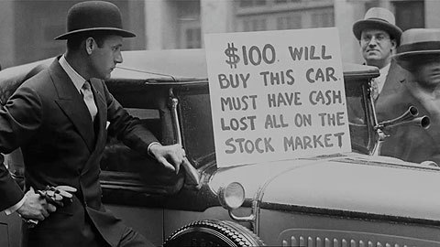 | http://www.wingclips.com/system/movie-clips/seabiscuit/the-great-depression/images/seabiscuit-movie-clip-screenshot-the-great-depression_large.jpg | This is just how desperate people were for money, especially those who crashed on the stock market. $100 for a car is extremely cheap in any era. People were selling whatever they could for whatever money possible.

Using the information from your chart write a journal entry from the perspective of an individual living in the USA during the Great Depression. Your journal should demonstrate an understanding of the hopeless situation many people were feeling. Make sure to refer to actual people and events from you examined in your journal.

April 9th 1931
We are at an all time low. We were forced to sell our house and now myself, Samantha, and the kids are living out of our car. While it is some form of shelter, I don’t know how much longer I can keep it up.
What am I supposed to tell the kids? They have no idea what is going on, and they keep asking “Daddy, when are you going to go back to work?” and “Why are we living in the car?” I don’t know how to tell them so they will understand.
I thought I was doing everything right. I had saved a little money, invested most of it into the stock market, but not all. Besides, the stock market seemed like a sure way to grow my money. I guess I was horribly wrong, along with millions of other Americans
We have been getting the odd meal at a private food bank, but the food is bland and the kids barely touch their meals anymore. Where is President Hoover in our time of need? He believes no one is starving, and we can manage on his own. Easy to say from the comfort of the White House. I would like to let him see the state in which his “do nothing” attitude has put my family.
I’ve been hearing about this new democrat leader, Roosevelt. Supposedly, he plan’s to put our lives back on track. People say he is gonna create jobs and stabilize the economy. Rumour is, too, that he wants to end the prohibition! I could really use a drink right about now.
Hopefully we can keep things together until he is in office, but I really don’t know. The bank is still after me, and I may have to sell the car. Where are we going to live? What are we going to eat? Those are questions that I do not know the answer to….

