Soviet Survivor
A Dice Based Roleplaying Game
Developed by Mr. J. Pereira
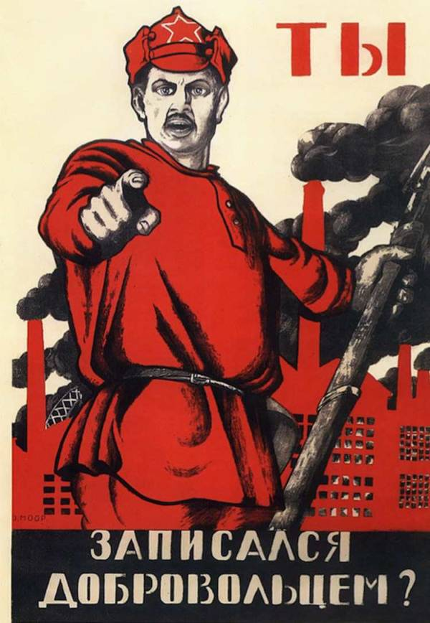
Revised by Mr. J. Pereira and Mr. A. Larsen, 2019

Introduction:

Soviet Survivor is a roleplaying game designed for History 12 students to simulate life and death for Russians between 1914 and 1941. Using the foundations of historical knowledge developed throughout the unit on Soviet History, students will develop characters that they will take through the early days of the Soviet Union, using dice to determine their survival in events much greater than themselves.
This collection of rules will provide the foundational knowledge required for teachers to utilize Soviet Survivor in their own classroom. The basics of gameplay will be discussed in the following rule book. In house rules are welcome, as you develop the game to suit the needs and interests of the students in your classroom.
Have fun and let the revolution begin!

What you need:

Class set – 6 sided dice X 2
1 – 20 sided dice (D20)
2 – Character sheets per student
1 – Events Sheet for teacher use only
1 – Class Card for each student character, outlining their special abilities

Pre-Game Preparation:

Each student begins by receiving TWO character sheets. On this sheet, they must write the name of their character on the NAME line. To determine their Class, the teacher selects the social class for the student characters. The number of peasants, kulaks, factory workers, Cossacks, and soldiers should be approximately equal. The officer class should be rare, with only two or three of the characters being assigned this class.
For example, a character sheet should look as such:
- Dmitri is a Peasant .
When every student has a character and class assigned to them, the students should get a Character Card which outlines the special abilities based on their class.

Gameplay:

At the start of the first turn, the teacher begins by reading the synopsis of events of the First World War from the events sheet. When they have finished reading the event description, they then must read the odds of survival to the class. The students then must in turn write the odds of survival for their own personal characters in the assigned space.
When the students are ready, they then must roll two 6 sided dice to determine if they survived the event.
For example, if a character is a peasant in the First World War, they must roll a 4-10 to survive. The student then writes 4-10 in their odds of survival space. The student then rolls two dice, resulting in a total of 5. They then write “5” in the results space with a brief explanation of what they imagined happened to their character during this event. The closer a number is to the cut off for survival, the closer they were to death in the imagined scenario. For example a 4 would be a near death experience, whereas a 7 would be a comfortable experience with no major trauma.
i. World War I - Odds of Survival: 4-10
Result: 5, caught stealing food from the German army, was beaten when he was discovered.

This gameplay pattern continues through the events. Participants all receive one free re-roll per game. This can be used at any time, and may save the character’s life. However, once it is used up, it cannot be used again. Some actions and classes may result in a character receiving an extra re-roll. One such example is victory in a battle between Cossacks and Soldiers. For more information, please read the rules of battle for Cossacks and Soldiers on page 6.
When a re-roll is used or gained, it must be recorded in the action column.
Additionally, when a player event occurs, such as escape, getting imprisoned in a gulag, publishing a book, or a promotion/demotion, it must be recorded in the action column.
Certain events require the player to roll a D20 dice. This dice should be loaned by the teacher for this particular roll. Follow the events guide to ascertain what rolls are needed for specific results on these events.

The goal of the game is for at least one of your characters to survive through to the great Purges and the start of the Second World War.

Special Abilities for Players

Military Officers:
- Can steal pips from any players by rolling two dice and the player who has the highest result gains two pips; the loser loses two pips. Officers receive +1 advantage versus anyone of lower status and – 1 versus secret police.
- Can switch fates with anyone of lesser status by following the same process as above with the exception that there is no advantage on the roll. Losing a roll causes the targeted player to automatically survive and the officer still rolls fate but has a minimum fate of being sent to the gulag.

NKVD Secret Police Officers: - Selected by teacher after Civil War Event
- Same powers as military officer plus the ability to steal as many re-rolls from players as they wish. Failure to win the roll-off results in loss of re-roll or two pips (at winners discretion).
- Has backstabbing powers. Can have anyone executed or sent to the gulag once in the game if they choose so. Doing so results in the favour of Stalin (one get out of the gulag free card which can also be used to reduce a sentence of execution to a term in the gulag).

- Both officers can denounce other players if they wish. If they win the roll the person who is denounced goes to the gulag and the officer gains their re-roll. If they lose they get sent to the gulag.

Soldiers:
- Can keep order when Cossacks create chaos. Successfully holding off the Cossacks results in the soldiers acquiring the Cossacks’ re-rolls of anyone they choose who were in the fight.
- Can be promoted to officer if the try to over throw an officer. They target the officer they want and then role to see if successful. They get a -1 modification to the role.

Cossacks:
- Can cause chaos. The more Cossacks the higher the likely-hood they will cause problems for all non-Cossack players. Successfully causing chaos results in Cossacks stealing selected players re-rolls who were in the fight.
- Can be promoted to officer if the try to over throw an officer. They target the officer they want and then role to see if successful. They get a -2 modification to the role because Cossacks are crazy. ; )

How to determine the winners of combat between Cossacks and soldiers...
- Ask if any Cossacks want to cause trouble. First with their hand up gets to be the leader. Then ask if any soldiers want to stop them. First with their hand up gets to be the leader. Then have all soldiers, Cossacks and officers write down on a scrap piece of paper if they are in the fight. Officers can help either side. The side with the most gets the equivalent + added on to their roll (i.e. Soldiers have 2 more people they get a +2). Tie goes to the side with the most supporters.
- The side that loses has its leader lose their re-roll. If they do not have a re-roll they roll to see if they are killed (if they roll a 7) or go to the gulag (a roll of 6 or 8). The leader of the winning side receives a reroll. The remaining winners number themselves and then roll a D20 to determine who receives the reroll.

