Part C: Conflict: Class, Social Economic Division and Social Change
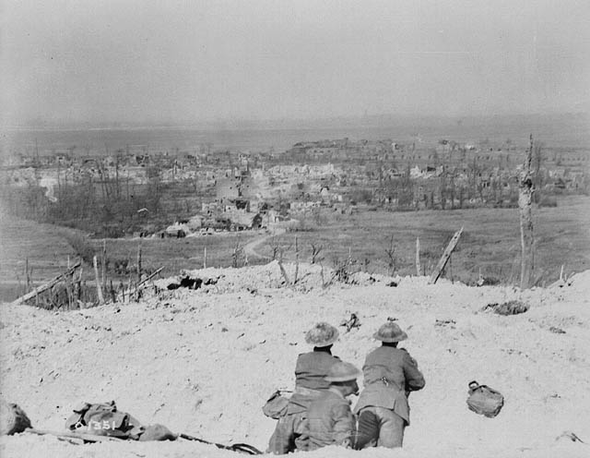 | Examine Source A, what does it tell you about the importance of this Canadian Victory? | 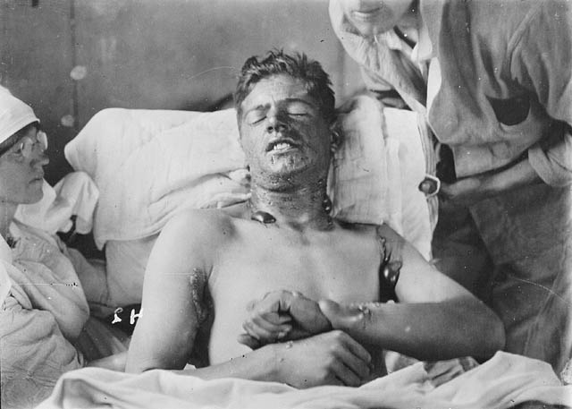 | At what Battle would this soldier in source B most likely have received this injuries at, explain why you think that?
 | Why would both sides want this location so badly? |  | What did the use of mustard gas indicate about the nature of warfare in World War One?
Source A - View over the crest of Vimy Ridge showing the village of Vimy , which was captured by Canadian troops |  | Source B - Unidentified Canadian soldier with burns caused by mustard gas
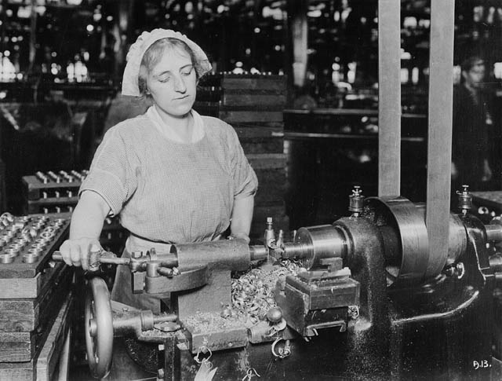  Source C | What about the above Source C indicates a big shift in Canada during World War One? | Source D  “When the war started I wanted to go, but I was too young, only fifteen. By the time I was seventeen, I couldn’t wait any longer. I guess I was afraid the war would end before I got a chance to get involved.” Author Unknown  “ | Source F  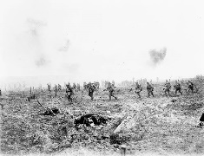
 | What about Source C might be controversial after the war was over, explain why? | Source E  “A lot of us were farm boys. Fighting was bound to be more exciting than farming and none of us thought we’d ever get another chance to see overseas places like England and France.” Authour Unknown
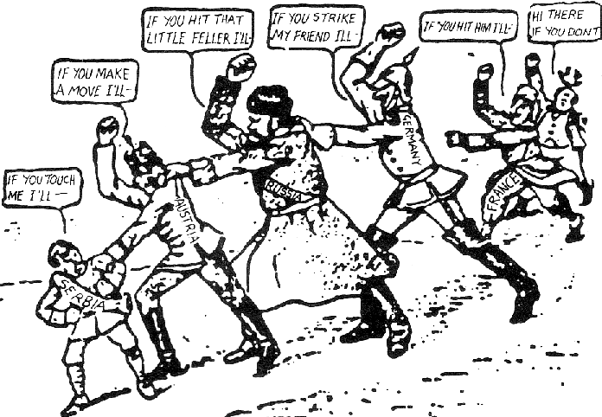  Source G | How Source G explain the outbreak of World War One? | Imagine the soldiers in Source F were the same people who are quoted in Source D and E. Write a short paragraph exprecing what they might be thinking after being on the front lines.

