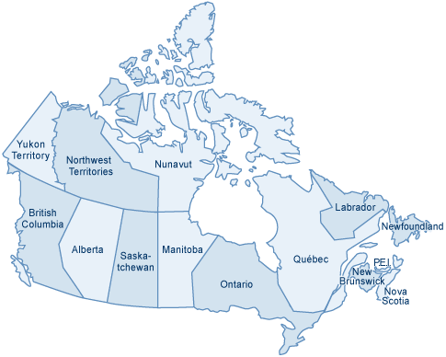
What do you Know?
What is the role of government?
Why do we have Government?

How do you create Government?
Name some parts of government in BC/Canada.

How does Government impact you?
How do you impact government?

