Rise of Totalitarianism

Rise of Totalitarianism
Totalitarianism is a form of government that theoretically allows the leader full control over the state and the lives of its people. Although Totalitarianism has been used since the dawn of society (ex: a Monarchy is a form of totalitarian government) the term totalitarian was not used until the early 1920’s when the father of fascism Benito Mussolini coined the term “totalitario” as a way of defining his fascist government.(1)

There are many paths a Totalitarian leader can go whether it’s the extreme right (fascism) or the extreme left (communism) or something more moderate ther are always constants. All totalitarian leaders have the similar if not the same fundamentals when it comes to ruling over the people.
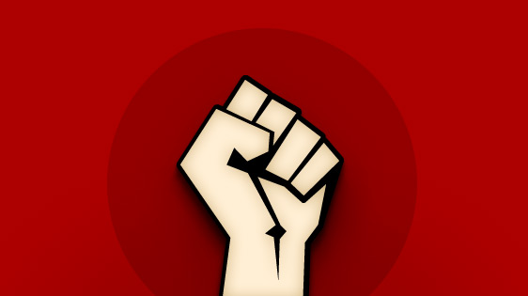(i)(
i

Cult Of Personality

North Korea: Its people worship its totalitarian leaders almost as gods with schools deifying the Kim family. North Korean leaders come from the Kim dynasty with Kim Il Sung who founded the country as it is today with his socialist “Juche” philosophy as the first in its bloodline. Out of the three Kim Il Sung was the most revered with the people calling him the “eternal leader” and his death sparking a ten day mourning period which halted most of the country. This mourning lasted a further 3 years although the everyday life still went on. His son and grandson are still revered but it is believed that Kim Il Sung’s cult of personality was the strongest and despite his death his son Kim Jong Il and grandson Kim Jong Un are often seen as under Kim Il Sung’s shadow.(2)

Italy: Benitio Mussolini bounded into the Italian political scene claiming boisterously he would bring back the Roman Empire. The Italian people sick of slow progress and being overlooked by other European powers immediately turned to their new “Caesar” and followed him reverently as the Italian believed he would be the turning point for Italy. Mussolini was extremely smart when it came to building his cult of personality he portrayed himself as emperor and used propaganda to paint his image he even went as far as using his face as an Italian flag replacement. He also knew to start young teaching the children Fascist ideals in school and further implanting that he was emperor. Mussolini also used a bit of his fear factor as anyone who opposed him was swiftly taken care of by his Black Shirt thugs.(3)

Indoctrination and Mobilization of Supporters
Cuba: Fidel Castro was Cubas Communist leader for almost 50 years and still is largely popular despite arguably causing the deaths of thousands of people and his death in 2016. Castro’s road to power began when he took up the fight against the U.S. backed right wing dictator Batista. Although he was a Marxist Castro was smart and knew if he openly came out as socialist he would lose the support of the more moderate rebels so he hid his true beliefs. Castro was handed a huge setback when his attempted rebel movement was crushed and he and many of his supporters were sent to jail, but Castro used this time to spread the word and teach the inmates about his ideas gathering more support. After his release Castro and his rebels went into hiding and began to conduct guerilla warfare against Batista and his regime. Castro spread the word of his movement through print and radio, when he attacked he would spare the prisoners and treat the wounded victims again another move increasing support as he was the only one standing up against the tyrannical Batista as Batista began to crack down more on the people Castro took his chance and seized power exposing Batista’s army’s weakness against guerilla warfare. Castro had to mobilize his supporters militarily in order to overthrow Cuba’s rightwing dictator and he did so expertly beating a modern army with his small inexperienced force.(4)

Soviet Union: The man of steel was ruthless and cunning using his what seemed insignificant position of party Secretary to pave his way to leader of the party. Stalin promoted those who liked him surrounding himself at the top with people who backed him and as he gained more and more power eventually beginning to dispose of those who stood against him. Stalin who has been underestimated by his own party was now in complete control, to gain the support of the people he used the late Vladimir Lenin’s image and began to erase those who sought to expose him from history removing them from photographs and staged mock trials to show the people that he was taking care of “enemies” of the state. Stalin also had a great deal of fear factor to him and often people were too afraid to not support him as you would end up dead or at a gulag if you didn’t.(5)

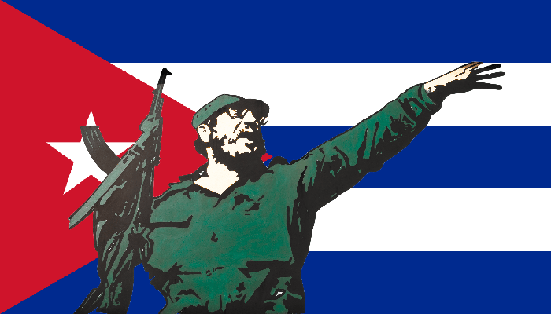
iii
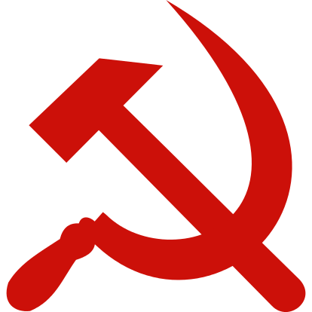ii

Usage of Propaganda and Control Over the Media

Germany: Adolf Hitler was crazy but he was also a master politician, Germany was in heavy economic depression people were starving and it had fallen from its super power status all because of world war 1 and the treaty of Versailles, all the German people wanted was a return to its prewar state and Hitler promised them that. Once in power Hitler took control of all media sources, He burned books and banned anything that wasn’t German, movies became nationalistic or racist against others and promoted militarism. He used propaganda to fuel the anger of a beaten nation as he transformed Germany back into a super power. He turned his people against minorities and portrayed Jews as semi human monsters allowing the slaughter of millions of people and the radicalization of Germany.(6)

Soviet Union: After Lenin’s death the people of the Soviet Union turned to the party for a new leader and Josef Stalin stepped forward using propaganda to gain the support of the people. First he took Lenin’s image and used it beside his own portraying himself as Lenin’s close friend and that he shared the same vision for Russia future this however was complete fabrication and propaganda as Lenin’s and Stalin’s relationship was strained at best and Lenin thought Stalin was the last person who should take over Russia. After he was firmly in power Stalin began to utilize propaganda in many different ways; he used one of the earliest forms of photo editing removing those who he disliked very image from history “cutting” them out of photographs. He also used propaganda to promote belief in communism often putting down western democracy and building up communism to show the people the Soviet Union was the best. Finally he promoted himself to the people showing himself as a Father like figure to Russia and portraying himself as an intellectual who would lead Russia to greatness.(5)
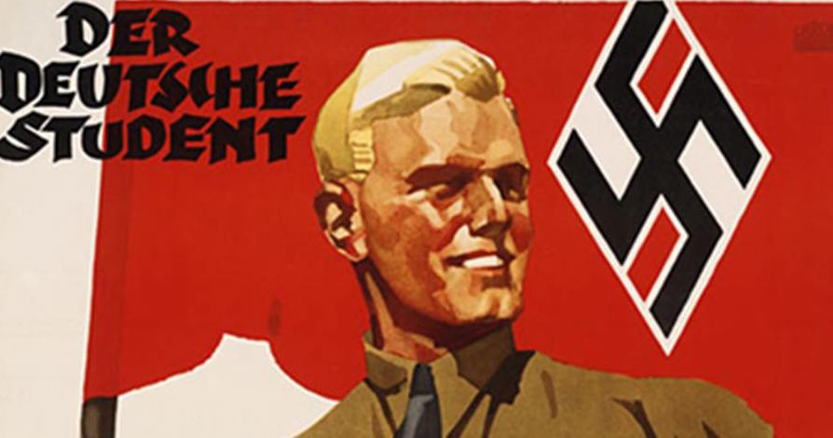
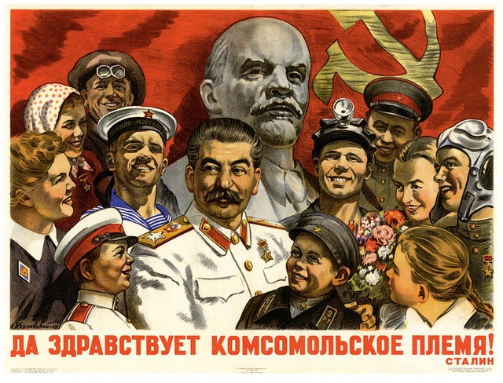
v
iv
Usage of Violence, Fear and Terror as a Tool
Cambodia: Pol Pot and his Khmer Rouge ruled over Cambodia with an iron fist using terror and violence to their advantage. Pot committed mass genocide killing all those in the previous government, minorities and intellectuals burying the dead in mass graves. One example of how he used terror would be the force feeding of pork to Muslims a forbidden food item in the Islamic faith if you refused you were tortured and killed. Pot also forced people out of the cities and onto collective farms where people could be controlled easier he created a “tell-tale “society in which citizens were encouraged to report wrong doers to police reportedly even children would report on their own parents. This is an ingenious usage of terror as it keeps people terrified of doing anything wrong and forces them into submission.(7)

Middle East: ISIS at terror group who holds territory throughout the middle east believes in a radicalized Muslim state in which all Muslims should follow the group uses terrorism as a military strategy attacking civilian targets for no reason often using terrifying weapons such as chlorine gas preventing countries from forming an effective defence plan. ISIS also uses social media for its advantage recruiting from all over the world and posting propaganda and executions as well to create more terror. ISIS effectively uses the element of the unknown to instill terror on its opponents who never know where the next attack will come from.(8)
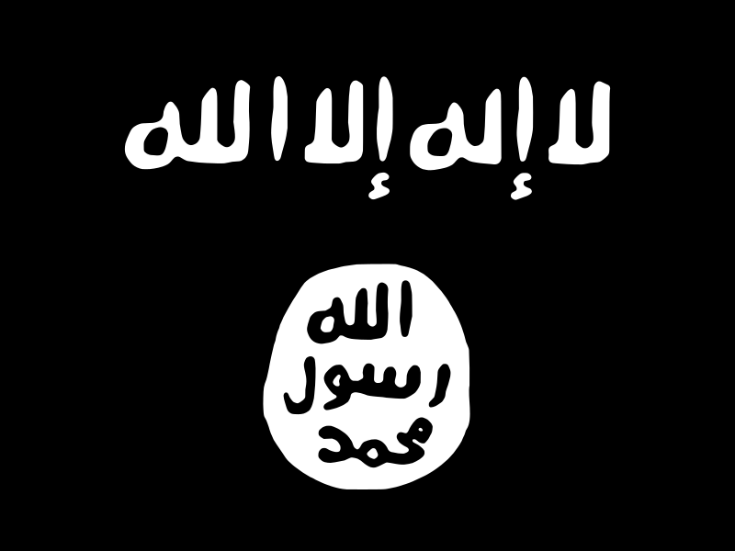
viii
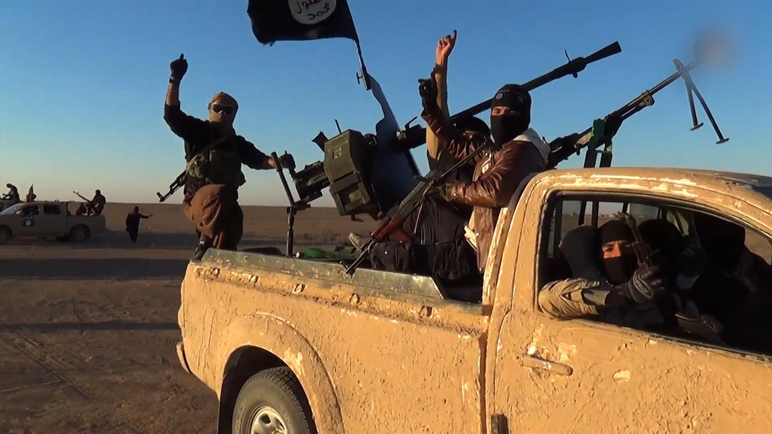ix
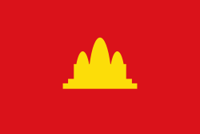vi
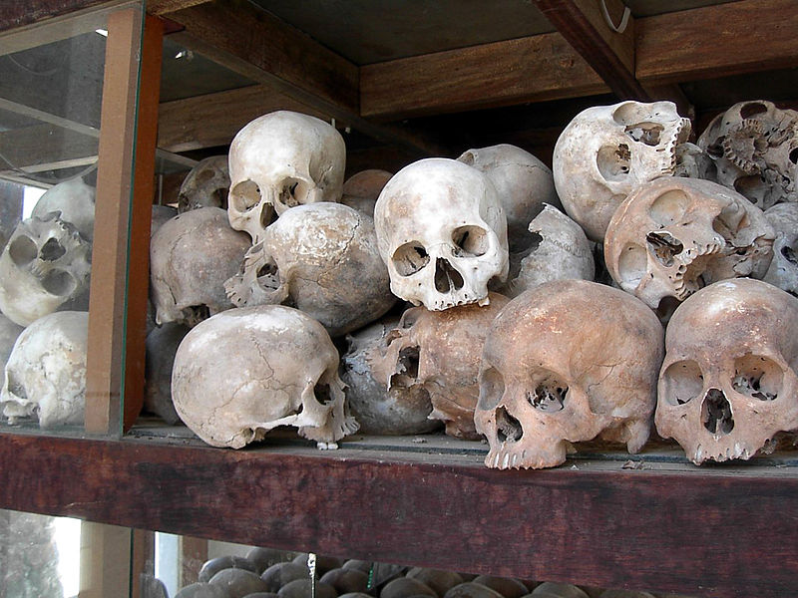vii
Removal of Opposition
China: Mao Zedong was chairman of the Chinese communist party he led an armed rebellion to topple the imperial regime in China. Once in power he created a one party state that allowed him to rule indefinitely anyone who opposed him was sent to work at labor camps modernizing the country side conditions were terrible and many died working in the camps. One example of Mao removing opposition comes from the Hundred flowers campaign which originally allowed and promoted freedom of speech and the arts in China but when Mao realized the people began to criticize and say what they really thought about his regime Mao cracked down on all those who opposed him again sending them to labor camps in the country side.(9)

Soviet Union: After the Russian revolution had come to an end Vladimir Lenin and his Bolsheviks created a one party communist state Lenin removed all opposition in the first great purge of Soviet Russia anyone who opposed Communism was executed, tortured and imprisoned or sent to work at a gulag Lenin was ruthless using his secret police and informers to spy on anyone suspected who had anti-communist views. Stalin however was a whole different level a constantly paranoid man Stalin saw enemies anywhere even if you were his friend he’d start to suspect you Stalin saw enemies where he had none and he cracked down on anyone who he thought was an enemy even more than Lenin had before him.(5)

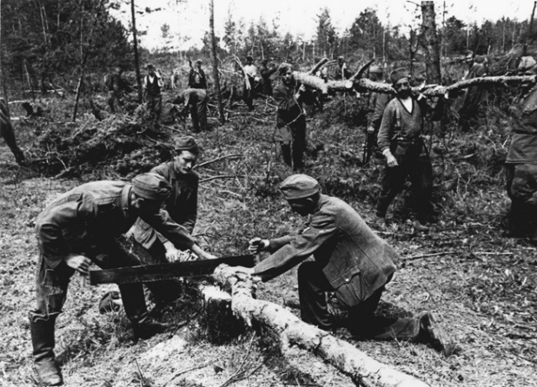 x
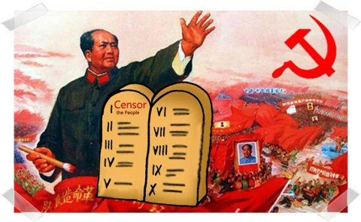xi

Aggressive Militarism and Glorification of War

Italy: Benito Mussolini promoted a return of the Roman empire he imagined a vast empire spanning the Mediterranean to be known as “Our sea” and hold land across North Africa controlling the entire Mediterranean and all trade in the region. He sought to modernize the Italian military and show the rest of the world who had snubbed Italy at the Paris Peace conference that Italy was a major power. He demonstrated his military might through parades and flashy arrangements he also staged an incident in Ethiopia the last independent area of Africa so he had an excuse to invade crushing the primitive Ethiopian army with Italy’s modern war machine. Looking for more world military proving grounds he sent a large Italian force to Spain to help the right wing Fascist Franco to topple Spain’s left wing government again Italy was successful and the triumphant Mussolini boasted about the strength of Fascism and Italy he was convinced Italy was a super power.(3)

Germany: Until the treaty of Versailles was signed Germany has a very strong militaristic history, Germans were proud of their countries great strength and sought during world war 1 to become the world’s most powerful nation. But they were defeated and Britain and France crushed Germany handing out massive war reparations and dismantling Germany’s great military. When Hitler comes onto scene he shares the desire of the people to return Germany to a world super power despite the terms of the treaty of Versailles he begins rebuilding in secret one example is disguising his air force the Luftwaffe as an air postal service and only revealing its true identity once it had reached a large size. Hitler also paraded his military often showing off his military right he promoted the idea of “Lebensraum” or living space for Germanic peoples he claimed land belonging to “undesirable” Eastern Europeans was rightfully Germany’s for the taking and Germany would need a strong military to take it giving the German people something to rally behind and fight for.(6)

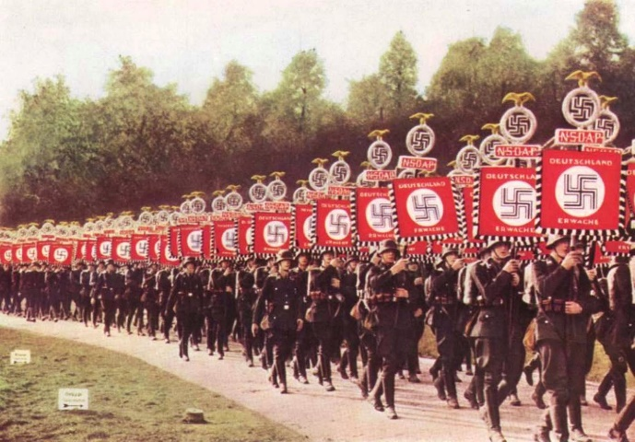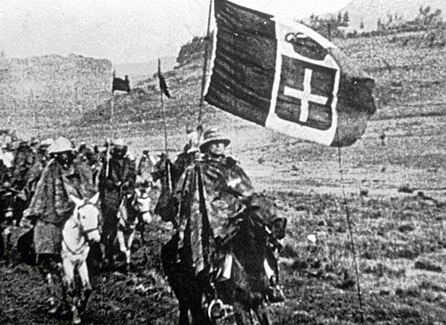

xii xiii

Promotion of Radical Beliefs

Germany: Hitler took a frustrated country in economic crisis and radicalized its people using the threat of communism and the promise of a return to German glory. Hitler convinced the people that Fascism was the way forward and the people followed him his loud charismatic speeches were always follows by applause and the chanting of “Heil Hitler” the people showed Hitler he had their loyalty and Hitler began to express even more radical ideas. One of Hitler core principles was his belief in the supremacy of the Aryan race (Blue eyes Blond hair) the supremacy of the Germanic people and he turned an entire nation into supporting this ridiculously racist belief. Germans began to see Minorities especially Jews as undesirable and sub-human he used propaganda and media to promote the beliefs and convinced a nation that a removal of these minorities was necessary for a greater good.(6)

Zimbabwe: Robert Mugabe was Zimbabwe’s socialist nationalistic president he believed that Zimbabwe’s deteriorating economy then called South Rhodesia was due to the fault of white land owners when elected he and his followers forcefully took the land from them promoting anti-colonial beliefs and strong African nationalism.
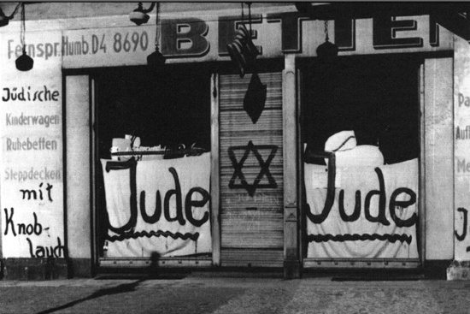 xi
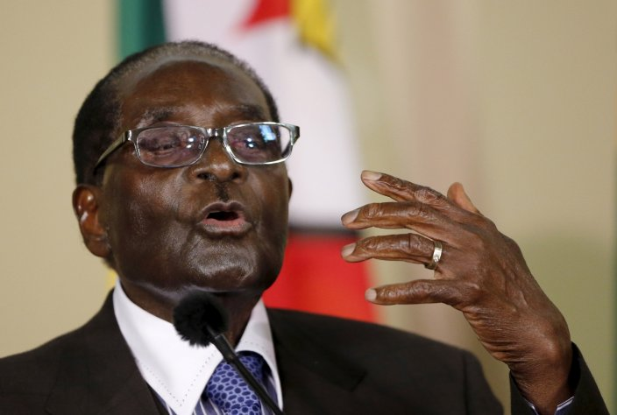 xv
Failure of Democracy

Germany: After world war 1 Germany setup its democratic Weimar government unfortunately though it was destined to fail almost as soon as it was formed it was forced to sign the treaty of Versailles forcing harsh reparations onto Germany and plunging the country into economic depression and allowing frustrated radicals to flourish prompting the support of radicals such as the communists and the fascists.(6)

Russia: After the October revolution a provisional democracy was set up unfortunately all of its members thought they were just that provisional so nothing was ever really done prompting frustration from the Russian people as the dire situation was not improving this allowed radicals to gain more support and ultimately allow the Bolsheviks to overthrow the provisional government and seize power for themselves.

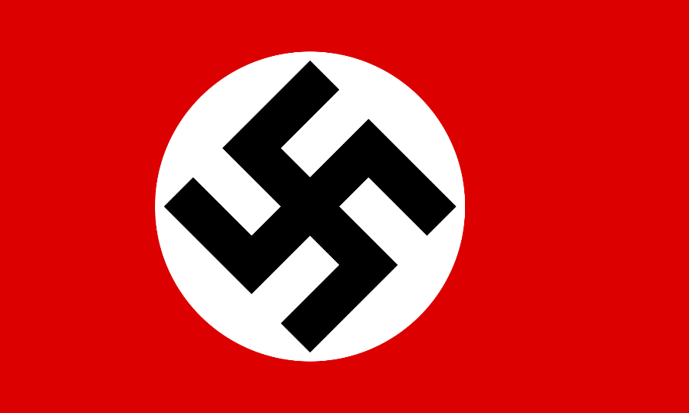 xvi
xvii

How did Totalitarian Leaders use the Conditions of the Early 1920’s to Rise to Power?
World War 1 had left Europe in a hopeless state whole countries had been left in ruins due to the brutal trench warfare that had taken place over the last 4 years. This meant that rebuilding would be extremely difficult with many countries loosing most industrial areas and many of the new small countries created based on Woodrow Wilson’s self-determination policy lacking the basic infrastructure to run and sustain themselves and has leaders who had no experience governing their own country. Most European nations took massive loans from the United States and then tried to print more money to repay them this lead to massive inflation especially in Germany who had to pay off its war guilt debt which led to economic depression over most of central and eastern Europe creating an ideal breeding ground for frustration and a want to change from the people and allowed radical groups such as communists and fascists to flourish as all it took was a smart politician who knew what to say and the people would follow. The first politician to take advantage of frustration of the people was Benito Mussolini in Italy in the early 1920’s Mussolini took advantage of Italy’s hopeless political setup and with a collaboration of his party and the other far right parties with the backing of rich corporate owners and his Blackshirt thugs he seized power with the support of the people promising change. Italy’s useless political system Mussolini wasn’t the only issue he had to use to his advantage he also had other issues to use to his favor. Like the rest of Europe Italy was hit hard by World War 1 it had been promised territory in exchange for the part it played in defeating Austria-Hungary but its allies basically ignored it at the victory table giving it only a fraction of the promised territory. The south of Italy was also extremely poor as only the north had been industrialized. Mussolini bounded onto the scene with his nationalistic ideas and public projects to industrialize all of Italy curb unemployment and end poverty and the people rejoiced as a totalitarian dictator became their leader.
On the left side of the spectrum in Russia conditions are even worse years of rule under the Romanov dynasty and usage of the feudal system has caused Russia to fall far behind the rest of Europe both militarily and economically there are huge gaps between the lower and upper classes and famine has become commonplace adding insult to injury Russia had lost a war against Japan and was being crushed by Germany the army was fed up and beginning to strike as were the peasants and workers rather than reform the Tsar brutally cracked down on opposition this lead to further frustration among the people and the communists rose up and began to push for revolution and a Russia where everyone was equal. Vladimir Lenin the leader of the communists famously used the slogan “peace land and bread” appealing to the peasants desires. Lenin drew his support from the working and peasant class and used its sheer numbers to seize power and create the world’s first Communist state ago to the delight of the people.

What Methods did Totalitarian Leaders use to maintain Their Power and Control over Their countries?
In order to keep control a totalitarian dictator has to control the lives of the state and its people while keeping the latter happy there are many ways for a dictator to carry this out but I will be focusing on 8 in my presentation. In my opinion the easiest way to stay in power is to keep the people happy. Sounds simple enough right? But how do you keep someone who you have complete control over happy, well you show them what they want to see there are many different ways to do this such as through actual progress (this often comes at a steep price) propaganda, (bend the truth so the people literally see what they want to see and only that) or when hardships do happen find someone else to blame (people love to blame others it is human nature to find a scape goat.) Using this and other methods totalitarian leaders flourished in Europe in the early to mid-20th century and why regimes continue to pop up today.

Bibliography
Sources
Britannica, The Editors of Encyclopaedia. “Totalitarianism.” Encyclopædia Britannica, Encyclopædia Britannica, Inc., 16 Aug. 2017, www.britannica.com/topic/totalitarianism. March 12 2018 (1)
“North Korea.” Wikipedia, Wikimedia Foundation, 15 Mar. 2018, en.wikipedia.org/wiki/North_Korea. March 12 2018 (2)
“Benito Mussolini.” Biography.com, A&E Networks Television, 3 Jan. 2018, www.biography.com/people/benito-mussolini-9419443. March 12 2018 (3)
“Fidel Castro.” Wikipedia, Wikimedia Foundation, 14 Mar. 2018, en.wikipedia.org/wiki/Fidel_Castro. March 12 2018 (4)
“Life in USSR under Stalin.” History Learning Site, www.historylearningsite.co.uk/modern-world-history-1918-to-1980/russia-1900-to-1939/life-in-ussr-under-stalin/. March 12 2018 (5)
“Nazi Propaganda.” United States Holocaust Memorial Museum, United States Holocaust Memorial Museum, www.ushmm.org/wlc/en/article.php?ModuleId=10005202. March 13 2018 (6)
“Khmer Rouge.” Wikipedia, Wikimedia Foundation, 17 Mar. 2018, en.wikipedia.org/wiki/Khmer_Rouge. March 13 2018 (7)
“Islamic State of Iraq and the Levant.” Wikipedia, Wikimedia Foundation, 15 Mar. 2018, en.wikipedia.org/wiki/Islamic_State_of_Iraq_and_the_Levant. March 13 2018 (8)
“Robert Mugabe.” Wikipedia, Wikimedia Foundation, 16 Mar. 2018, en.wikipedia.org/wiki/Robert_Mugabe. March 15 2018 (9)
Photos
Ciotti, Gregory. “Stop Being a Customer Support Dictator.” Help Scout Blog, 6 Feb. 2013, www.helpscout.net/blog/quality-customer-service/. March 12 2018 (i)
“Bans on Communist Symbols.” Wikipedia, Wikimedia Foundation, 8 Mar. 2018, en.wikipedia.org/wiki/Bans_on_Communist_symbols#/media/File:Hammer_and_sickle_red_on_transparent.svg. March 12 2018 (ii)
“Fidel Castro.” Wikipedia, Wikimedia Foundation, 14 Mar. 2018, en.wikipedia.org/wiki/Fidel_Castro. March 12 2018 (iii)
“Stalin's Cult of Personality: Its Origins and Progression.” The York Historian, 8 Apr. 2016, theyorkhistorian.com/2015/09/18/stalins-cult-of-personality-its-origins-and-progression/. March 13 2018 (ix)

Ruiz, Mauricio, et al. “State of Deception: The Power of Nazi Propaganda.” Brussels Express, 22 Jan. 2018, brussels-express.eu/state-deception-power-nazi-propaganda/. March 13 2018 (v)
“Khmer Rouge.” Wikipedia, Wikimedia Foundation, 17 Mar. 2018, en.wikipedia.org/wiki/Khmer_Rouge. March 13 2018 (vi) (vii)
“Islamic State of Iraq and the Levant.” Wikipedia, Wikimedia Foundation, 15 Mar. 2018, en.wikipedia.org/wiki/Islamic_State_of_Iraq_and_the_Levant. March 13 2018 (viii) (ix)
Site Navigation.” Warfare History Network, warfarehistorynetwork.com/daily/wwii/gottfried-p-dulias-surviving-the-soviet-gulag/. March 15 2018 (x)
“Guest Post: Google.cn Pulls Out of Communist China.” Techrights, 24 Mar. 2010, techrights.org/2010/03/24/situation-in-china-told-by-china/. March 15 2018 (xi)
“Color Photos from Pre-War Nazi Germany.” Rare Historical Photos, 18 Feb. 2018, rarehistoricalphotos.com/color-photos-from-nazi-germany/. March 16 2018 (xii)
http://maximietteita.blogspot.ca/2014/11/etiopia-1935-second-italo-ethiopian-war.htmlv March 16 2018 (xiii)
https://www.bu.edu/today/2014/final-sale/ March 16 2018 (xvi)
“Post–World War II Legality of Nazi Flags.” Wikipedia, Wikimedia Foundation, 6 Feb. 2018, en.wikipedia.org/wiki/Post%E2%80%93World_War_II_legality_of_Nazi_flags#/media/File:Flag_of_the_German_Reich_(1935%E2%80%931945).svg. March 16 2018 (xvii)

