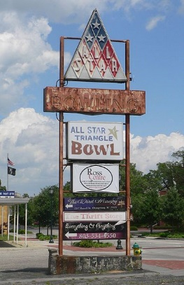
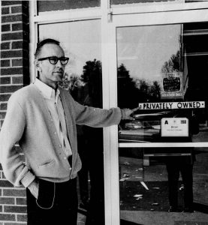
On February 8 1968, 27 university students were wounded and 3 were killed by gunshots fired by police. It all started with the racist owner of All Star Triangle bowling lanes in Orangeburg, South Carolina. After the passage of the Civil Rights Act of 1964, segregation had officially ended in much of the South, but it hadn’t changed the attitudes of some of its white citizens. Harry-Floyd (below) was one of these people. He stated that the Act didn’t apply to his establishment because it was private property. ^{[1]} Orangeburg’s black community was determined to change his mind. Floyd refused to remove his segregation after black leaders would try time and time again to convince him. He stated that it would “offend his long time clientele”. On February 5, 1968, a small group of local university students went to All-Star Triangle Bowling Lanes to protest its whites-only policy. Floyd refused them entry and they left peacefully. Word of Floyd’s refusal spread like wildfire. ^{[3]}
(4)
The Orangeburg Massacre
The next night a larger crowd came to protest Floyd’s policy and were met by police who threatened to blast them with firehoses. The unarmed students fought back by taunting the police, and the protest escalated quickly. Soon a plate glass window was broken and the officers were beating the students with batons.
The word spread once again about the protest. Tensions were escalating in Orangeburg and the people were enraged. Governor Robert McNair insisted that “Black Power” leaders were causing the student’s uproar and called the National Guard, tanks included, to intimidate the students into not resisting again. ^{[5]}
(5)
By Thursday, February 8, 1968 hundreds of students had gathered on South Carolina State’s campus to protest racial segregation at the bowling alley and other privately-owned establishments. This time they were accompanied by Cleveland Sellers who was a civil rights activist who had just graduated from Howard University. However, his activism put him on the police’s radar as a possible threat.

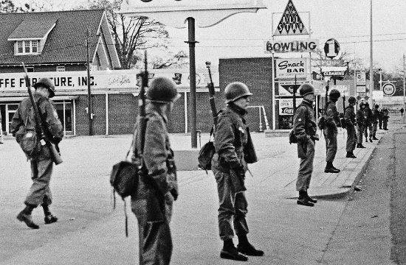
Heavy law enforcement joined by the National Guard troops were commanded by Chief Pete Strom to keep the protestors on Campus and prevent them from starting a riot. Many of the police officers had shotguns and, once again, none of the protestors were armed.
(6)
(2)
It wasn’t long before violence erupted on campus. The students started a large bonfire in front of the entrance. They taunted the law enforcement and threw rocks and other objects at them. As firefighters were putting out the fire, a police officer was hit with a heavy wooden banister. ^{[7]}
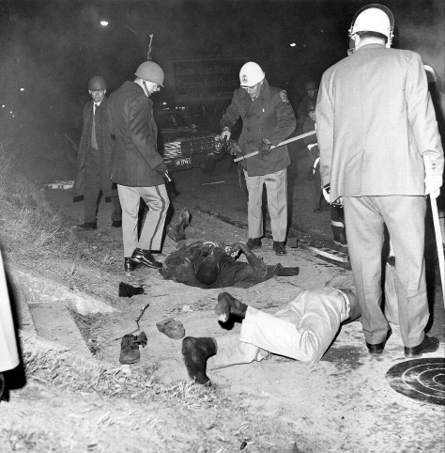
A highway patrolman then fired his gun into the air in an attempt to calm the crowd. Upon hearing the shot, other officers, thinking they were being fired upon, raised their guns and opened fire on the protestors in the dark.^{[9]} “It lit up the area just as if it were daylight,” recalls Sophomore Carolyn Lloyd, who survived the horror of this event.^{[10]}
(8)
At least 27 protestors were shot and wounded, mostly in the side or back as they fled. Among these people were Sammy Hammond (18), Delano Middleton (17), and Henry Smith (18) who lost their lives in the assault. ^{[11]}
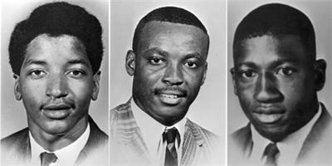(12)
Sellers was taken into custody at the hospital and charged with inciting a riot. ^{[13]}
The Orangeburg Massacre happened within days of the Tet Offensive in the Vietnam War and just weeks before the assassination of Martin Luther King Jr. ^{[14]} it was therefore largely overlooked by the press. The incident “barely penetrated the nation’s consciousness,” writes Jack Bass in his 1970 book The Orangeburg Massacre. ^{[15]}
“We still ask ourselves, ‘Why?’ It was said we had weapons. We had no weapons. We had nothing to defend ourselves.”
In addition, some of the press coverage was incorrect, adding details that would change the mood of the story. For example, one report from the Associated Press claimed that the protestors had been armed. The black community was horrified by the slaughter and the following bad press. Many started protests of their own. ^{[16]}
Civil rights leader Martin Luther King Jr. sent a telegram to President Lyndon B. Johnson stating that the deaths in Orangeburg “lie on the conscience of Chief Storm and the government of South Carolina.” ^{[17]}
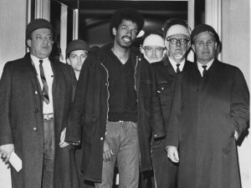
After the conviction of Sellers (below), the state of South Carolina ended investigations involving the Orangeburg Massacre. The nine officers responsible for the shooting were brought to trial for use of excessive force at the campus protest, but all were acquitted. No one was held accountable for the students killed and injured that night.
(18)
Survivors are still fighting for recognition for what happened to them. A survivor explains his feelings on the bad press in saying “We still ask ourselves, ‘Why?’ It was said we had weapons. We had no weapons. We had nothing to defend ourselves.” ^{[19]}
This event is important in history because it was one of the 40 cities that experienced student protests in 1960. It was a changing point in the civil rights movement seeing in a couple years everything would change. It contributed to the end of segregation in privately owned establishments, and therefore made a powerful impact on the 20th century. ^{[20]}

End notes
1 "Orangeburg Massacre - Facts & Summary - HISTORY.com." $site. June 12, 2018. $publisher, Web. June 12, 2018. https://www.history.com/topics/orangeburg-massacre
2 "The Orangeburg Massacre – 1968 in American Memory." $site. June 13, 2018. $publisher, Web. June 13, 2018. http://1968inmemory.web.unc.edu/2018/04/the-orangeburg-massacre/
3 "Orangeburg Massacre - Facts & Summary - HISTORY.com." $site. June 12, 2018. $publisher, Web. June 12, 2018. https://www.history.com/topics/orangeburg-massacre
4 "File:All-Star Bowling Alley (Orangeburg SC) sign from SW 1.JPG - Wikimedia Commons." $site. June 14, 2018. $publisher, Web. June 14, 2018. https://commons.wikimedia.org/wiki/File:All-Star_Bowling_Alley_(Orangeburg_SC)_sign_from_SW_1.JPG
5 "Orangeburg Massacre - Facts & Summary - HISTORY.com." $site. June 12, 2018. $publisher, Web. June 12, 2018. https://www.history.com/topics/orangeburg-massacre
6 "Orangeburg Massacre survivors fight for remembrance of bloodiest civil rights event in S.C. history | News | postandcourier.com." $site. June 17, 2018. $publisher, Web. June 17, 2018. https://www.postandcourier.com/news/orangeburg-massacre-survivors-fight-for-remembrance-of-bloodiest-civil-rights/article_66cd9b1e-0604-11e8-a307-036240bdda75.html
7 "The Orangeburg Massacre – 1968 in American Memory." $site. June 13, 2018. $publisher, Web. June 13, 2018. http://1968inmemory.web.unc.edu/2018/04/the-orangeburg-massacre/
8 "Orangeburg Massacre (1968) | The Black Past: Remembered and Reclaimed." $site. June 13, 2018. $publisher, Web. June 13, 2018. http://www.blackpast.org/aah/orangeburg-massacre-1968
9 "The Orangeburg Massacre – 1968 in American Memory." $site. June 13, 2018. $publisher, Web. June 13, 2018. http://1968inmemory.web.unc.edu/2018/04/the-orangeburg-massacre/
10 "Orangeburg Massacre still stings 50 years later | Charlotte Observer." $site. June 14, 2018. $publisher, Web. June 14, 2018. http://www.charlotteobserver.com/news/local/article198943934.html
11 "The Orangeburg Massacre – 1968 in American Memory." $site. June 13, 2018. $publisher, Web. June 13, 2018. http://1968inmemory.web.unc.edu/2018/04/the-orangeburg-massacre/
12 "Historical Significance - The Orangeburg Massacre." $site. June 13, 2018. $publisher, Web. June 13, 2018. https://93816725.weebly.com/historical-significance.html
13 "Cleveland Sellers, 48 years after the Orangeburg Massacre | The Christian Century." $site. June 14, 2018. $publisher, Web. June 14, 2018. https://www.christiancentury.org/blogs/archive/2016-03/cleveland-sellers-48-years-after-orangeburg-massacre
14 "Orangeburg Massacre still stings 50 years later | Charlotte Observer." $site. June 14, 2018. $publisher, Web. June 14, 2018. http://www.charlotteobserver.com/news/local/article198943934.html
15"Orangeburg Massacre - Facts & Summary - HISTORY.com." $site. June 12, 2018. $publisher, Web. June 12, 2018. https://www.history.com/topics/orangeburg-massacre
16 "The Orangeburg Massacre – 1968 in American Memory." $site. June 13, 2018. $publisher, Web. June 13, 2018. http://1968inmemory.web.unc.edu/2018/04/the-orangeburg-massacre/
17 "Orangeburg Massacre - Facts & Summary - HISTORY.com." $site. June 12, 2018. $publisher, Web. June 12, 2018. https://www.history.com/topics/orangeburg-massacre
18 "In 1968, Three Students Were Killed by Police. Today, Few Remember the Orangeburg Massacre | History | Smithsonian." $site. June 14, 2018. $publisher, Web. June 14, 2018. https://www.smithsonianmag.com/history/1968-three-students-were-killed-police-today-few-remember-orangeburg-massacre-180968092/
19 "Orangeburg Massacre (1968) | The Black Past: Remembered and Reclaimed." $site. June 14, 2018. $publisher, Web. June 14, 2018. http://www.blackpast.org/aah/orangeburg-massacre-1968
20 "Historical Significance - The Orangeburg Massacre." $site. June 13, 2018. $publisher, Web. June 13, 2018. https://93816725.weebly.com/historical-significance.html

