Watts Riots of 1965
Segregation in the United States between white people and African Americans was prominent in the 1960’s. Tensions between the two were high, and peace between them was fragile (1). A quote to give you an example of the tension: “Hating people because of their color is wrong. And it doesn't matter which color does the hating. It's just plain wrong (2)”
On August 11, 1965, the fragility of the peace was tested in the Watts region of Los Angeles, USA (3). Watts was a part of Los Angeles where a majority of the population was African American (4).
The conflict started between a young African American man, Marquette Frye, and a local white police officer. The officer pulled over Frye while he was in his car based on suspicion that Frye was driving while intoxicated (5). The officer then told Frye that he was going to arrest him for drunk driving and that his car will get towed. Frye and the officer began to argue, and shoving was involved. The crowd was beginning to grow as well. The crowd had grown from 75 people to about 300 on this hot night (6).
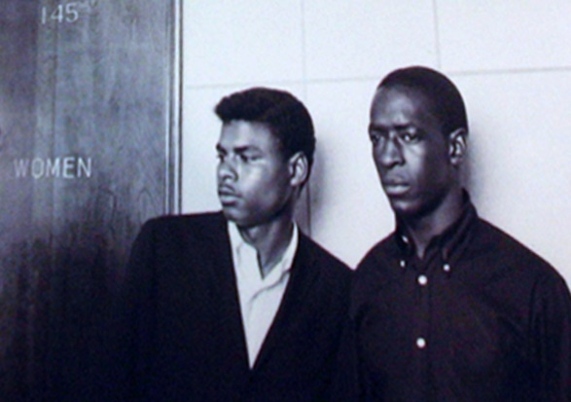
Frye (left) and his brother, Ronald (7).
The riots went on for six days. Once it was all finally over, 34 people had died, over 1 000 injuries were reported, and 4 000 arrests were made. The real blow of the event though, was that there was more than $40 million in damage to the Watts region in south LA (8).
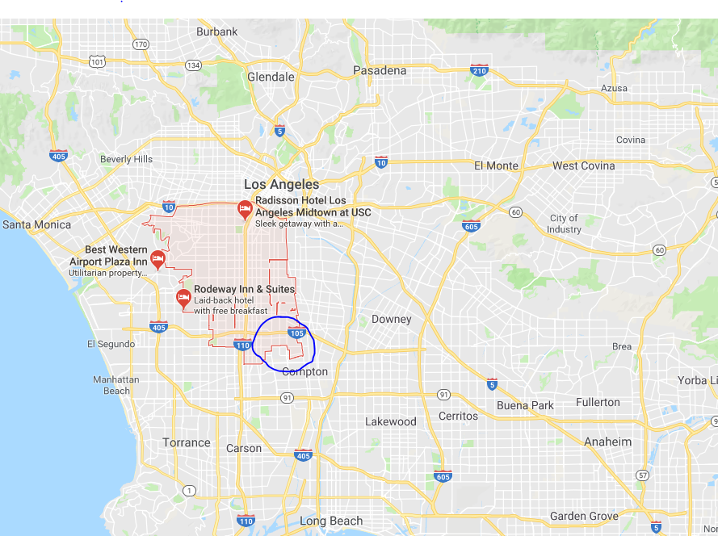
A map of Los Angeles and the Watts region

The riot quickly had escalated for a number of reasons. As Frye was being arrested, his mother arrived at the scene and was yelling at the officer. People heard his mother’s screams, and many began spreading the rumor that the officer was beating up an elderly woman (9).
The Riot lasted for six days. During these days, stores were being robbed and brawls were breaking out everywhere between the people of Watts and the poloce. Cars and buildings were also being lit on fire, and the firefighters couldn’t even go and stop the fires because the police were so busy that they couldn’t protect the firefighters from the rioters (10).
“Don’t worry; we’re going to burn this mother down.” (11). A quote that Frye heard from one of his friends as he was being arrested.
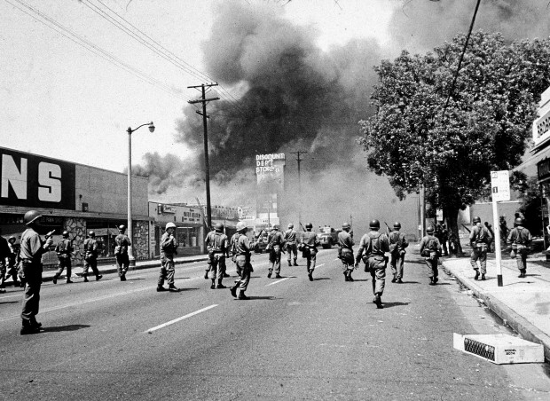
A day fire in Watts, LA (12)
The arrest of Frye wasn’t the entire reason the Watts riot happened, it was actually the breaking point in tensions between the African-American people and the white people in LA. There was a large racial division between the white authority and the African American locals (13).
“A child born to a Black mother in a state like Mississippi… has exactly the same rights as a white baby born to the wealthiest person in the United States. It’s not true, but I challenge anyone to say it is not a goal worth working for.” (14). A quote about racism in the United States by Marshall Thurgood (1908-1993), who was an African American lawyer during this time (15).
After the riots were over, it was discovered that most of the 34 people declared dead were African American (16). After the riots, many looked into why the riots happened and realized that the riots weren’t committed by criminals, but by average citizens. They were rebelling about the incredibly high unemployment rates and poor schooling in the Watts area (17).
The importance of the Watts riots was that it was a large step for the African American people in the civil rights movement. Many of the citizens were speaking out about their rights and the way that they were mistreated. The white people were now scared of what would happen if they continued the way they were going after seeing the riots (18).

The legacy of the Watts riots lives on today because racism against people of African descent is still very real (19).
"To live anywhere in the world today and be against equality because of race or color is like living in Alaska and being against snow." (20)
A quote that says how racism is becoming a redundant problem. Quote from William Faulkner, an American writer (21).

End Notes
- "1960's Civil Rights Movement History | Jim Crow Laws | Martin Luther King Jr." $site. June 11, 2018. $publisher, Web. June 11, 2018. http://www.historybits.com/civilrights.htm

- "Racism Sayings and Racism Quotes | Wise Old Sayings." $site. June 11, 2018. $publisher, Web. June 11, 2018. http://www.wiseoldsayings.com/racism-quotes/

- "Watts Riots." $site. June 11, 2018. $publisher, Web. June 11, 2018. http://crdl.usg.edu/events/watts_riots/?Welcome

- "Watts Riots in Los Angeles 50 Years Ago: Why Did They Happen? | Time." $site. June 15, 2018. $publisher, Web. June 15, 2018. http://time.com/3974595/watts-riot-1965-history/

- "Watts Riots." $site. June 15, 2018. $publisher, Web. June 15, 2018. http://crdl.usg.edu/events/watts_riots/?Welcome

- "Watts Riots- South Central history" $site. June 15, 2018. $publisher, Web. June 15, 2018. http://www.southcentralhistory.com/watts-riots.php

- "Revisiting the 1965 Watts Rebellion: Relics of Fire | KCET." $site. June 11, 2018. $publisher, Web. June 11, 2018. https://www.kcet.org/shows/departures/revisiting-the-1965-watts-rebellion-relics-of-fire

- "Watts Riots of 1965 | American history | Britannica.com." $site. June 11, 2018. $publisher, Web. June 11, 2018. https://www.britannica.com/event/Watts-Riots-of-1965

- "Decades After L.A. Riots, Watts Still Suffers : NPR." $site. June 12, 2018. $publisher, Web. June 12, 2018. https://www.npr.org/templates/story/story.php?storyId=4795093

- "Watts Riots." $site. June 11, 2018. $publisher, Web. June 11, 2018. http://crdl.usg.edu/events/watts_riots/?Welcome

- . "Marquette Frye, Whose Arrest Ignited the Watts Riots in 1965, Dies at Age 42". $site. June 14, 2018. $publisher, Web. June 14, 2018. http://www.latimes.com/local/obituaries/la-me-marquette-frye-obituary-19861225-story.html

- "Revisiting the Watts riots 50 years later: ‘the explosion was almost predictable’ – Daily News." $site. June 14, 2018. $publisher, Web. June 14, 2018. https://www.dailynews.com/2015/08/08/revisiting-the-watts-riots-50-years-later-the-explosion-was-almost-predictable/

- "Watts, 50 Years On, Stands in Contrast to Today’s Conflicts - The New York Times." $site. June 14, 2018. $publisher, Web. June 14, 2018. https://www.nytimes.com/2015/08/11/us/50-years-after-watts-riots-a-recovery-is-in-progress.html

- "Thurgood Marshall Quotes." $site. June 15, 2018. $publisher, Web. June 15, 2018. http://thurgoodmarshall.com/quotes-by-thurgood-marshall/

- "The Case Thurgood Marshall Never Forgot | Smart News | Smithsonian." $site. June 15, 2018. $publisher, Web. June 15, 2018. https://www.smithsonianmag.com/smart-news/case-thurgood-marshall-never-forgot-180964637/

- "Watts Riots - Facts & Summary - HISTORY.com." $site. June 15, 2018. $publisher, Web. June 15, 2018. https://www.history.com/topics/watts-riots

- "A Huey P. Newton Story - Times - Watts Riots | PBS." $site. June 15, 2018. $publisher, Web. June 15, 2018. http://www.pbs.org/hueypnewton/times/times_watts.html

- "The Case for Civil Unrest: The Watts Riots and Institutional Racism – Black Power in American Memory." $site. June 15, 2018. $publisher, Web. June 15, 2018. http://blackpower.web.unc.edu/2017/04/the-case-for-civil-unrest-the-watts-riots-and-institutional-racism/

- "92 Percent Of African-Americans Say Black Americans Face Discrimination Today : NPR." $site. June 15, 2018. $publisher, Web. June 15, 2018. https://www.npr.org/2017/10/24/559889541/92-percent-of-african-americans-say-black-americans-face-discrimination-today

- "Famous Quotes About Racism." $site. June 15, 2018. $publisher, Web. June 15, 2018. https://quotabulary.com/famous-quotes-about-racism

- "William Faulkner | Biography & Works | Britannica.com." $site. June 15, 2018. $publisher, Web. June 15, 2018. https://www.britannica.com/biography/William-Faulkner

Bibliography
"1960's Civil Rights Movement History | Jim Crow Laws | Martin Luther King Jr." $site. June 11, 2018. $publisher, Web. June 11, 2018. http://www.historybits.com/civilrights.htm

"92 Percent Of African-Americans Say Black Americans Face Discrimination Today : NPR." $site. June 15, 2018. $publisher, Web. June 15, 2018. https://www.npr.org/2017/10/24/559889541/92-percent-of-african-americans-say-black-americans-face-discrimination-today

"A Huey P. Newton Story - Times - Watts Riots | PBS." $site. June 15, 2018. $publisher, Web. June 15, 2018. http://www.pbs.org/hueypnewton/times/times_watts.html

"Decades After L.A. Riots, Watts Still Suffers : NPR." $site. June 12, 2018. $publisher, Web. June 12, 2018. https://www.npr.org/templates/story/story.php?storyId=4795093

"Famous Quotes About Racism." $site. June 15, 2018. $publisher, Web. June 15, 2018. https://quotabulary.com/famous-quotes-about-racism

"Marquette Frye, Whose Arrest Ignited the Watts Riots in 1965, Dies at Age 42". $site. June 14, 2018. $publisher, Web. June 14, 2018. http://www.latimes.com/local/obituaries/la-me-marquette-frye-obituary-19861225-story.html

"Racism Sayings and Racism Quotes | Wise Old Sayings." $site. June 11, 2018. $publisher, Web. June 11, 2018. http://www.wiseoldsayings.com/racism-quotes/

"Revisiting the 1965 Watts Rebellion: Relics of Fire | KCET." $site. June 11, 2018. $publisher, Web. June 11, 2018. https://www.kcet.org/shows/departures/revisiting-the-1965-watts-rebellion-relics-of-fire

"Revisiting the Watts riots 50 years later: ‘the explosion was almost predictable’ – Daily News." $site. June 14, 2018. $publisher, Web. June 14, 2018. https://www.dailynews.com/2015/08/08/revisiting-the-watts-riots-50-years-later-the-explosion-was-almost-predictable/

"The Case for Civil Unrest: The Watts Riots and Institutional Racism – Black Power in American Memory." $site. June 15, 2018. $publisher, Web. June 15, 2018. http://blackpower.web.unc.edu/2017/04/the-case-for-civil-unrest-the-watts-riots-and-institutional-racism/

"The Case Thurgood Marshall Never Forgot | Smart News | Smithsonian." $site. June 15, 2018. $publisher, Web. June 15, 2018. https://www.smithsonianmag.com/smart-news/case-thurgood-marshall-never-forgot-180964637/

"Thurgood Marshall Quotes." $site. June 15, 2018. $publisher, Web. June 15, 2018. http://thurgoodmarshall.com/quotes-by-thurgood-marshall/

"Watts Riots." $site. June 15, 2018. $publisher, Web. June 15, 2018. http://crdl.usg.edu/events/watts_riots/?Welcome

"Watts, 50 Years On, Stands in Contrast to Today’s Conflicts - The New York Times." $site. June 14, 2018. $publisher, Web. June 14, 2018. https://www.nytimes.com/2015/08/11/us/50-years-after-watts-riots-a-recovery-is-in-progress.html

"Watts Riots - Facts & Summary - HISTORY.com." $site. June 15, 2018. $publisher, Web. June 15, 2018. https://www.history.com/topics/watts-riots

"Watts Riots in Los Angeles 50 Years Ago: Why Did They Happen? | Time." $site. June 15, 2018. $publisher, Web. June 15, 2018. http://time.com/3974595/watts-riot-1965-history/

"Watts Riots of 1965 | American history | Britannica.com." $site. June 11, 2018. $publisher, Web. June 11, 2018. https://www.britannica.com/event/Watts-Riots-of-1965

"Watts Riots- South Central history" $site. June 15, 2018. $publisher, Web. June 15, 2018. http://www.southcentralhistory.com/wa

