Socials Studies 10 Name/Date:
Residential School Sources: Home for Christmas

- Use a colour code or other coding method and highlight words or phrases in the letter that you stand out for you?
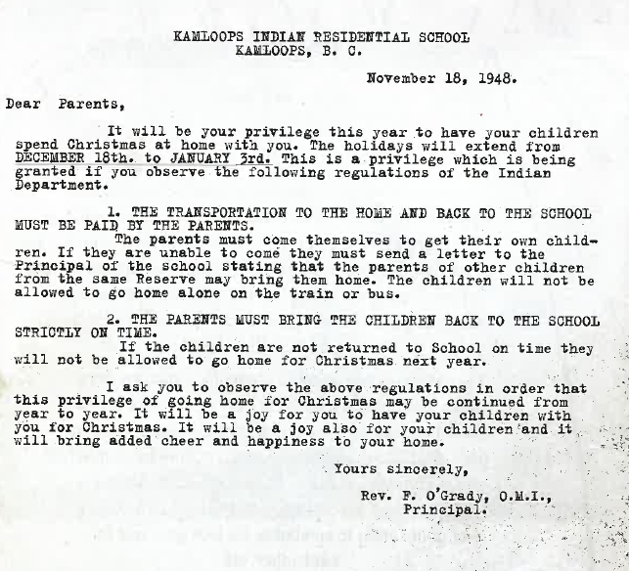

- Using your coding method explain why you highlighted each item (what was it that made you pick out that item from the letter?)

- What do you think this letter says top the parents about the relationship between the students, parents and the school?

- Imagine what Christmas would be like for the children who did not get to go home? What do you think it would be like?

