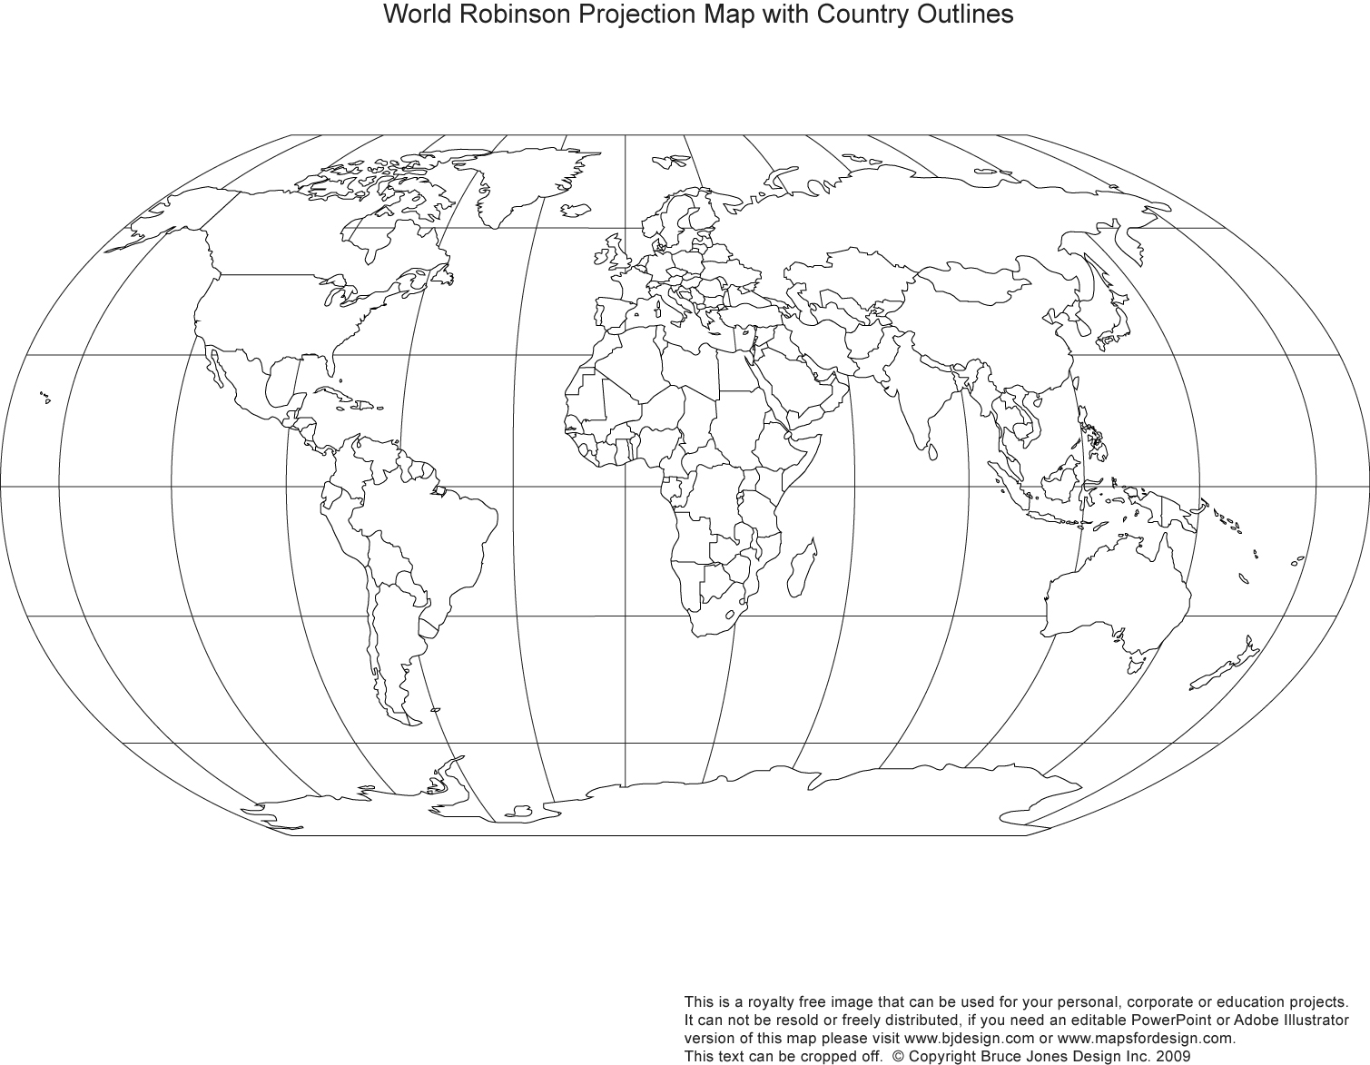

**MAP OF THE WORLD**

**Social Studies**  Global Awareness: Current Events

Name: ________________________________

Date: _________________________________

When and where did it occur? **Show location on map as well\***

Who is directly involved or affected (people, companies, countries, groups)?

How might this event be significant to you?

Event #1:

What’s going on? How would you explain this to someone?

Source:

**\*Remember to properly cite your source\***

How is bias shown in this story?

How might it be resolved?

**Instructions**: Find an event that has occurred over the past **two weeks** that has **global significance**. Complete the boxes. On the other side of the paper, find an event that has occurred over the past **two weeks** that has a **Canadian significance**. Complete the boxes.

Why is this happening?

Give multiple examples of opinion or fact in the source?

**MAP OF CANADA**

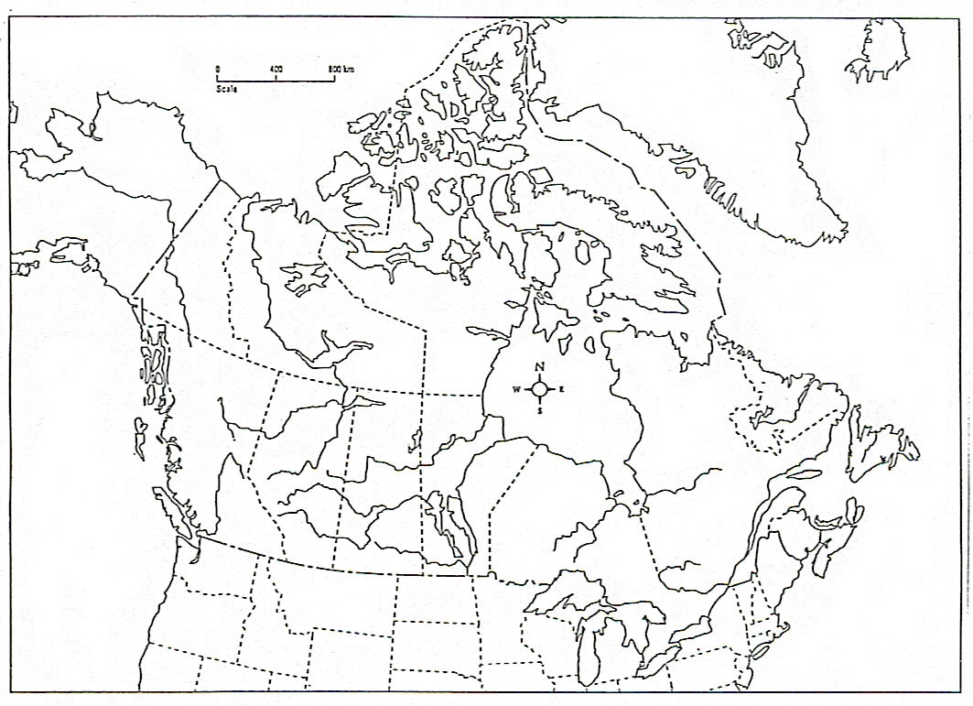

Source:

**\*Remember to properly cite your source\***

Event #1:

What’s going on? How would you explain this to someone?

How is bias shown in this story?

**\***

When and where did it occur? **Show location on map as well\***

Why is this happening?

How might it be resolved?

Who is directly involved or affected (people, companies, countries, groups)?

How might this event be significant to you?

Give multiple examples of opinion or fact in the source?