History 12 Name/Date: Jordan McMillan

Unit 2: Promise and Collapse
Topic: U.S. – The Interwar Years
Assignment: Exploring the Boom and the Bust
Reference: Student Workbook pp. 62-73
http://memory.loc.gov/ammem/fsahtml/fahome.html
http://www.ecommcode.com/hoover/hooveronline/hoover_and_the_depression/letters/index.html
LINK DOESN’T WORK

http://lcweb2.loc.gov/ammem/afctshtml/tshome.html
http://history1900s.about.com/od/photographs/tp/greatdepressionpictures.htm

http://www.shmoop.com/greatdepression/botw/primarysources.html?d=http://historymatters.gmu.edu/d/5111/ LINK DOESN’T WORK

Other online sources

Task: Examine a variety of online primary source documents, including images, letters and speeches that illustrate the effects of the Great Depression. Some examples may include:
- Letters to Herbert Hoover from desperate families
- Drought on the prairies
- Breadlines or soup kitchens

In a chart similar to the one below and record your impressions based on the source focussing on questions such as:
- What do the images/documents show?
- What do they reveal about the time period and how they lived?
- How do images demonstrate a change from the “roaring twenties”?

Primary Source | Reference (link) | Impression
Pp. 65 Herbert Hoover’s time in office. | Student Workbook  pp. 62-73 | The text book explains that Hoover was great at making money, a trait he and the US would’ve benefited from in the 1920’s. However Hoover and his staff unfortunately did not see the impending depression nor did he do anything to alleviate the situation. He believed it was against the American way to intervene and would be useless to try.
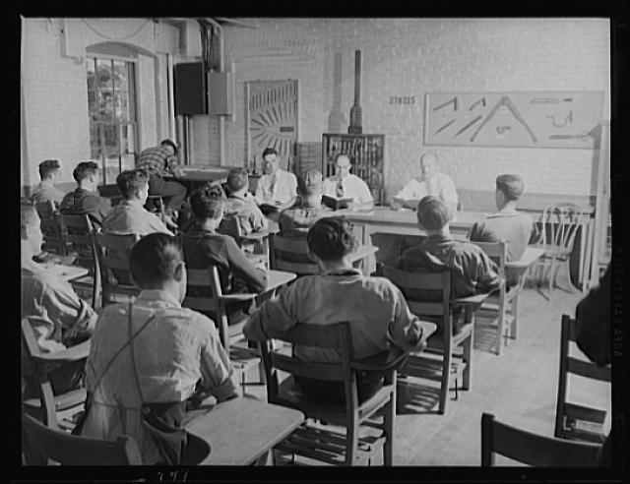 | http://memory.loc.gov/ammem/fsahtml/fahome.html | Boys in class: 1940  Image shows boys in class at a war production program. The boys thought of this as school and the class work would be to teach them to become expert die and tool markers. Stark contrast between the 1920’s as most boys would be in proper school receiving an education, not trying to get a job in a factory.
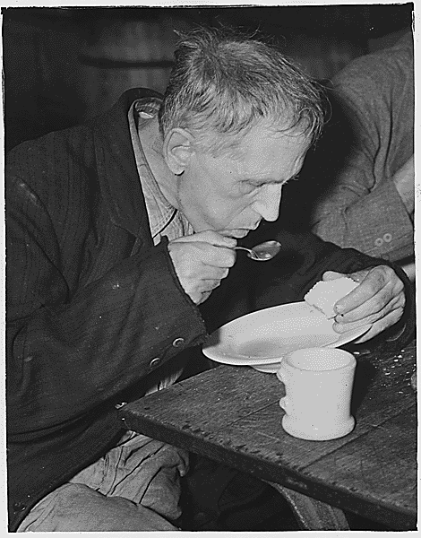 | http://history1900s.about.com/od/photographs/tp/greatdepressionpictures.htm | Unemployed man in soup kitchen: 1936  So many people were unemployed during the great depression that soup kitchens and bread lines were opened by charitable organizations looking to feed the hungry people of America. Is quite different from the 20’s when everyone had an overabundance of food.
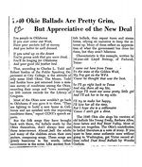 | http://lcweb2.loc.gov/ammem/afctshtml/tshome.html | Newspaper clipping: Aug 10, 1941  Illustrates the “grim” conditions of the depression through the lyrics. Mentions how people travelled to California to find fertile land and the WPA providing work. Unlike the upbeat jazz times of the 20’s the depressing outlook within the song goes to show how differently people felt about the situation they are in.
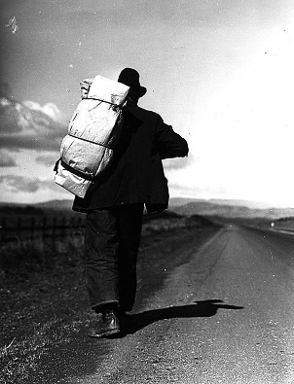 | http://history1900s.about.com/od/photographs/tp/greatdepressionpictures.htm | California Highway: 1935  Many were forced from their homes in an attempt to find work. Some people would go to California hoping to find work on a farm. Others would travel the train tracks going from town to town only able to take with them what they could carry.
Pp. 69 Unemployment | Student  Workbook  pp. 62-73 | As time went on in the depression, unemployment also became worse. About 25% of the available work force was without work which also further reduced demand. There were no ways of having any money either due to the fact that there were no welfare payments or unemployment insurance. That fact changed though when Roosevelt was in office. In the 1930’s the government established social security and pension programs to help get people spending their money again.

Using the information from your chart write a journal entry from the perspective of an individual living in the USA during the Great Depression. Your journal should demonstrate an understanding of the hopeless situation many people were feeling. Make sure to refer to actual people and events from you examined in your journal.

Great Depression Perspective Journal
August 10th, 1941
I woke up hungry, just like I have every other day for as long as I could remember. It has been so long since I’ve felt the security of cash in my pocket and the comfortability of a full stomach. I got up early just like I do every day, wishing I could go back to the dreams that take me away from this despair that I live in. Today I go to the factory, it’s the only one left running in town. They teach us boys how to operate the machinery in hopes that we’ll be able to there someday. After school I go to plant trees. It’s the only way for a boy my age to make any money these days. It can be hard work but at least it fills the boredom of the desolate days ahead. Usually after work I’ll take my little brother with me to the soup kitchens. There we stand in lines waiting for our share of bread and soup that never seems to satisfy. While we eat we listen to the drone of voices collecting into a tune. They sing of the dust fields, of lush California, love, and the need for money. Over the years I’ve had many friends depart our home town, heading west in search of work and better times. Honestly life has goptten so much better already. I still remember when we had hoover as President. The man expected the people of America to dig themselves out of the depression. Didn’t even wanna try and help us poor souls. Now Roosevelt on the other hand, that guy did wonders for us. He created jobs, my dad has one with the WPA, doesn’t pay much but hey, it’s way better than nothing. Never used to have these soup kitchens either. The guys done wonders for us. I here on his “fire side chats” that he’s even working on getting us some kind of unemployment insurance, which pays even if you don’t work! I can see better times ahead with this Roosevelt in control.

