Exploring the Boom and Bust
Primary Source | Link Used | Impression
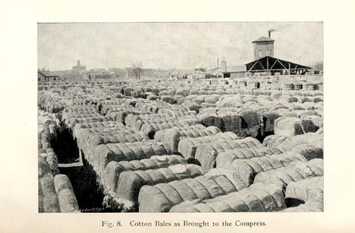 | https://infograph.venngage.com/p/192770/great-depression | This has an impression on me because it was a good visual representation of the amount of grain that was just sitting because of overproduction.
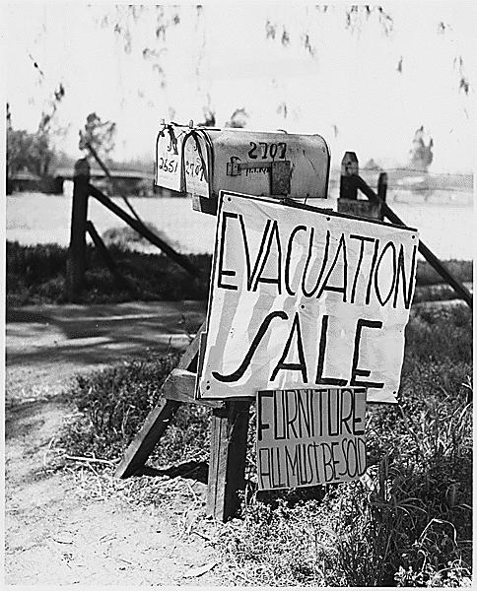 | https://www.thoughtco.com/great-depression-pictures-1779916 | This was significant to me because the farmer who owned the house was so desperate for money that he sold his own house with all of his furniture in it just to get some money.
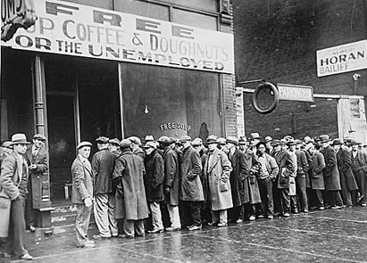 | http://www.lawyersgunsmoneyblog.com/2016/07/how-many-aba-law-schools-are-going-to-go-out-of-business | This image put into perspective how many people were unable to support themselves ad had to rely on things like this soup kitchen to be able to eat.
A fourteen year old girl  Dows, Iowa  March 24, 1934  Dear Mis. Roosevelt  I am a girl 14 yrs. old I am asking a favor of you & a big one to. Will you please send me some cloths or some money for some If you can. My girl friend wrote to. we both don't have any cloths. The kids at school all make fun of you if you can't dress just so please let me here from you & please dont publish this letter or us girls shall get a terriable beaten.  -May god bless you | www.clarenceschools.org/cms/.../Great%20Depression%20Primary%20Documents.do.. | The letter stuck out to me because it really put into perspective how desperate people were and hopeless that they would send letters to the First Lady asking for things like clothes.
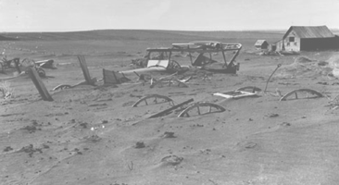 | http://www.english.illinois.edu/maps/depression/dustbowl.htm | This image made it obvious as to why the dust bowls in the Midwest ruined any hopes for farmers living there because there was so much sand being blown around
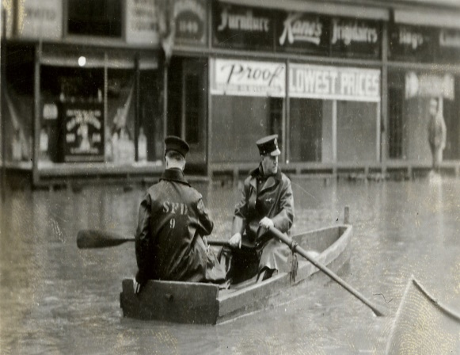 | https://www.massmoments.org/moment-details/flood-devastates-springfield.html | In contrast to the dust bowls in the Midwest, down in the Southern States there was brutal flooding going on. Everyday normal life was so much more difficult after the flood.

Atchinson, Kansas
October 17, 1934
To my loving wife,
Honey, I know it won’t surprise you to hear, but things aren’t going well. I’m living with cousin Ricky right now, but foods getting tight, and he doesn’t have any savings left to pay the rent after he blew it all in the stocks. I’m picking corn out here right now getting a quarter a day, but the soil here is getting real dry, and the dust is burning my lungs. I home every day dry as a desert and worn right down. I miss you so much sugar, and I hope you get the money in my letter in time to feed yourself and the kids. I miss you bad honey. I promise that as soon as I get on my feet, I’ll come back to y’all.\
Lots of Love, Jerry

